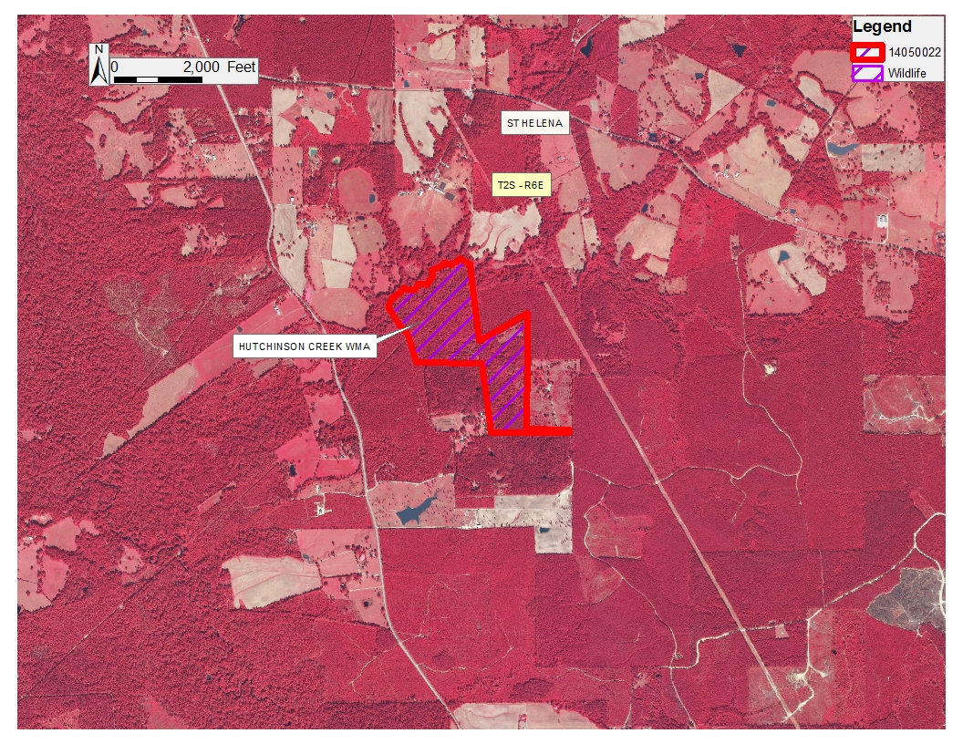

Office of Mineral Resources, Acres: 129.00 Tract Number: 43920