SCOPE OF SERVICES

MAINTENANCE OF EQUIPMENT
FOR
THE COASTAL PROTECTION AND RESTORATION AUTHORITY (CPRA)

Sabine Refuge Marsh Creation Project (CS-28-2) Cycle II Permanent Pipeline

- INTRODUCTION

The Sabine Refuge Marsh Creation Project (CS-28-2) Cycle II Permanent Pipeline was approved on the Coastal Wetlands Planning, Protection, and Restoration Act (CWPPRA) Eighth Priority Project List. The Sabine Refuge Marsh Creation Project Cycle II consists of approximately 3.54 miles of 29 inch inside diameter permanent pipeline, along with two fenced in temporary booster pump connections, all within Cameron Parish. The location of the pipeline is immediately south of the Hackberry community and runs perpendicular to LA State Highway 27, commencing near Mile 13.3 of the Calcasieu River Ship Channel and terminating at the northeastern corner of the Sabine National Wildlife Refuge. The project features are shown on (Attachment #1).

The purpose of the permanent pipeline is to be utilized in the transport of dredged material
for additional cycles of marsh creation on the Sabine National Wildlife Refuge in conjunction with the USACE maintenance dredging of the Calcasieu River Ship Channel.
The pipeline is also available for other parties to pump into for beneficially used or dedicated dredging projects in the area.

The Coastal Protection and Restoration Authority (CPRA) along with the U.S. Dept. of Interior, Fish and Wildlife Service (FWS) and the U.S. Army, Corps of Engineers (COE) are providing financial and technical support for operating the Sabine Refuge Marsh Creation Project (CS-28-2) Cycle II Permanent Pipeline. The proper maintenance associated with the Project is essential in achieving the long-term benefits envisioned and prescribed in the Operation and Maintenance Agreement.

The objective of this scope is to carry out the maintenance measures necessary for the project.

- CONTRACT TERM

The term of this contract will be for one (1) year, with an option to renew at the same price, terms and conditions for two (2) additional twelve (12) month periods not to exceed a total of thirty-six (36) months.

- LAND OWNER REQUIREMENTS

The construction components associated with this project are located on rights-of-way currently held by CPRA, the United States of America, and partially on the Sabine National Wildlife Refuge. CPRA will make contact with all of the landowners within the pipeline corridor prior to bidding to advise them that this maintenance contract will soon be awarded.

The bidders will be instructed on ingress and egress locations into the pipeline corridor off of LA Hwy 27 for grass cutting purposes using amphibious equipment. The two above ground booster pump locations can be accessed from LA Hwy 27 and Maggie Hebert Road (Attachment #2).

- ITEMS OF WORK

- General Information

- Contractor will provide mobilization to and from pipeline and booster pump connection locations. (Attachment #2)
- No specific certification is required, other than general knowledge and experience in using mechanical equipment, painting and general labor. A Louisiana Contractor’s License is not required.
- Approximately 1 per cent of the pipeline is above ground.
- Airboats will be allowed for navigation and access within the pipeline corridor, but not for maintenance of the vegetation.
- No underwater mowing is required.
- Spraying of weeds/vegetation only allowed inside the two Temporary Pumping facility locations.
- Should anything unforeseen develop, we will have to negotiate a change order or handle it through a separate bid package. Change orders must be approved by the Office of State Purchasing.

- Quarterly Maintenance

- Verify blind flanges on pipeline ends are installed.
- Verify Temporary Pumping Facilities are secure. Repair minor fence damage as required.
- Verify signage is still in place and replace if necessary (Prior approval by CPRA required).
- Remove/spray weeds inside Temporary Pumping Facilities.
- Cut weeds around outside perimeter of fence at Temporary Pumping Facilities. (Five foot extent of weed cutting around fence.)
- Cut weeds within a 30 foot wide corridor above the pipeline location (15 feet either side of the centerline) to facilitate visual inspection. (As-built plans will be provided for alignment and Contractor stakeout).
- This work will be accomplished by use of small amphibious equipment capable of operating a shredder or rotary cutter and able to traverse small bodies of water and navigate through wet/marsh areas (similar to Marsh Master or other equivalent).
- Contractor shall exercise care in performing this task so as to minimize damage, ruts, etc. to the existing terrain within the pipeline corridor.
- Contractor shall also provide protection of the pavement on LA Hwy 27 should the amphibious equipment cross over from one side of the corridor to the other (i.e., used rubber tires, plywood, etc.). Any damage to the roadway surface shall be repaired at the contractor’s expense.
- Contractor shall not impede local traffic along LA Hwy 27 when loading/offloading equipment for access into the pipeline corridor. A flagman shall be provided to ensure traffic safety when performing this task.
- Contractor shall take down any fences as needed to gain access into the pipeline corridor for each quarterly event. Once complete the fences shall be replaced in kind. Contractor shall be allowed to provide additional fence posts and associated hardware to make swinging gates for future access.

- Yearly Maintenance

- Check for corrosion on above ground pipeline portions. If corrosion is present, see Section 5 below for repairs. (Approval from CPRA required prior to making any coating repairs).
- Inspect pipeline corridor for issues, such as, sinkholes, boils, etc.
- Inspect pipeline above ground supports. Visually verify condition of concrete.

The “Contractor” will furnish all the necessary personnel and equipment including water transportation (if needed), to properly maintain the project in accordance with the instructions of the CPRA Project O&M Manager and as outlined in this scope of services.

- MAINTENANCE PROCEDURES

- Pipeline Coating Repairs

The following repairs shall be performed for damage(s) to the pipeline coating:

- If rusting has not occurred to damaged location(s), paint may be applied directly over the existing cleaned surface. For areas where rusting has occurred, remove the rust either by blasting to SSPC SP 5/NACE No. 1, “White Metal Blast Cleaning” or using a “bristle blaster” to SSPC SP 11 in order to obtain a comparable white metal surface.

- Clean surfaces to remove deposits of grease or oil in accordance with SSPC SP 1.

- Seal edges where paint has been removed with appropriate thinner.

- Use Formula V-766e, Vinyl-Type White (or Gray for alternating coats) paint for repairs to damaged sections. Paint shall be applied in accordance with manufacturer’s recommendations in approximately one and one-half (1.5) mils coats to obtain an average minimum dry film thickness of seven and one-half (7.5) mils for the completed system, and the thickness at any point shall not be less than six (6.0) mils. Final coat shall be white in color. The specified total film thickness shall be attained in any event. Attaining the specified film thickness in fewer than the prescribed number of coats or spray passes will be acceptable provided heavier applications do not cause an increase in pinholes, bubbles, blisters, or voids in the dried film and also provided that no more than two (2.0) mils (dry film thickness) per double spray coat nor more than one (1.0) mil per single spray pass of paint shall be applied at one time.

e. Dry film thickness measurements shall be made with an instrument with an accuracy of plus or minus three percent (+/- 3%) or better. The instrument shall be calibrated and used in accordance with ASTM D 7091. It shall be calibrated using plastic shims with metal practically identical in composition and surface preparation to that being coated, and of substantially the same thickness (except that for measurements on metal thicker than one-fourth (1/4) inch, the instrument may be calibrated on metal with a minimum thickness of ¼ inch). Frequency of measurements shall be as recommended for field measurements by ASTM D 7091 and reported as the mean for each spot determination. The instruments shall be calibrated or calibration verified prior to, during, and after each use.

6. DELIVERABLES

The Contractor will submit reports providing the information below. These reports are to be submitted on a quarterly basis as shown below.

- Dates and type of maintenance work performed during the reporting period, including digital pictures of all project features.

One (1) original report will be sent to Darrell J. Pontiff, P.E., Project Manager, CPRA, P.O. Box 62027, Lafayette, LA 70596-2027

One (1) original report will be sent to Robert Dubois, Project Manager, USFWS, 646 Cajundome Blvd., Lafayette, LA 70506

One (1) original report will be sent to Department of the Army, New Orleans District, Corps of Engineers, Attn: Scott Wandell, Projects and Restoration Branch, PM-B, P.O. Box 60267, New Orleans, LA 70160-0267.

For Payment Send Invoice To:
CPRA
Attn: Darrell J. Pontiff, P.E.
P.O. Box 62027
Lafayette, LA 70596-2027

ATTACHMENT #1

PROJECT FEATURES MAP

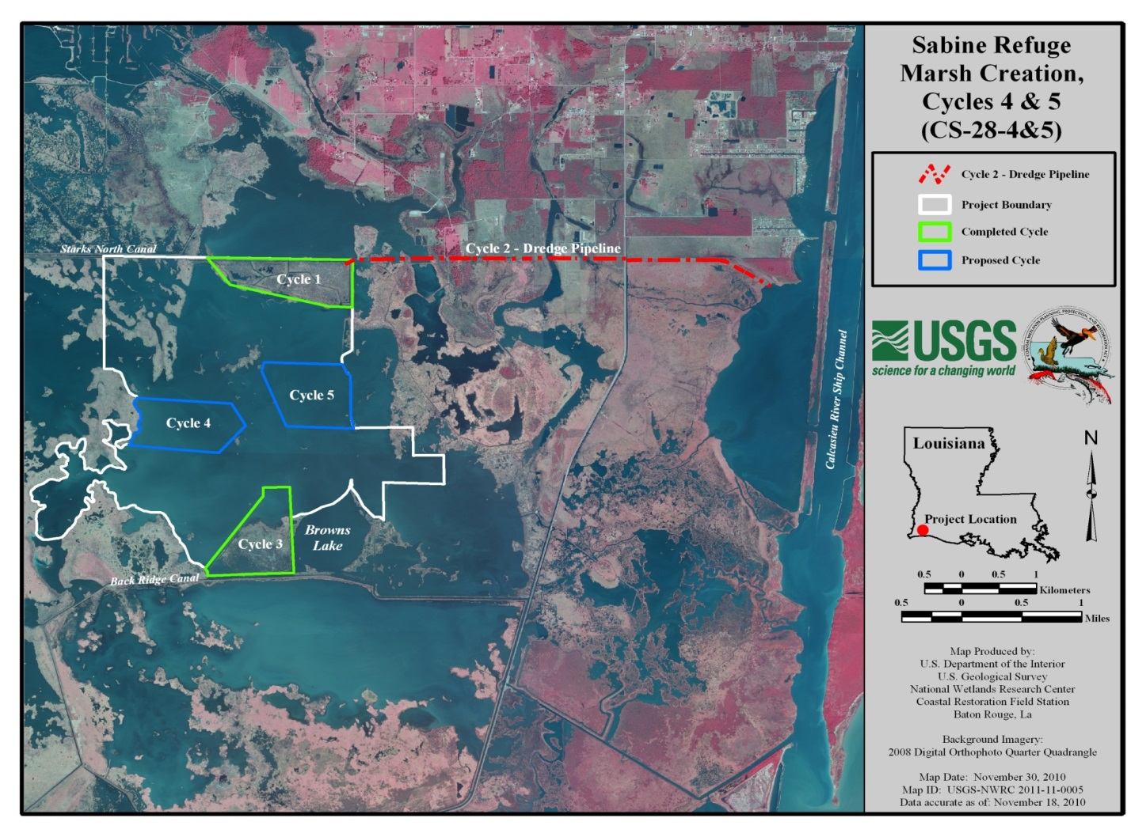

ATTACHMENT #2

PROJECT FEATURES LOCATION & DESCRIPTION

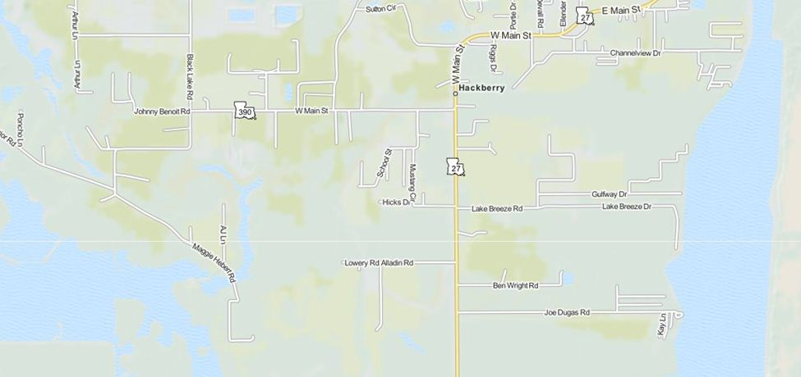
West Bland Flange Connection
Pipeline Location
East Blind Flange Connection
West Temporary Pumping Facility Location
East Temporary Pumping Facility

Temporary Pumping Facilities (Two Locations, West and East)

Each temporary pumping facility consists of a 29 inch inside diameter flanged pipe spool above ground with concrete supports, six foot chain link fence with three strands of barbed wire (dimensions 80 feet by 20 feet), warning signs, and 12 foot double gate with padlock.

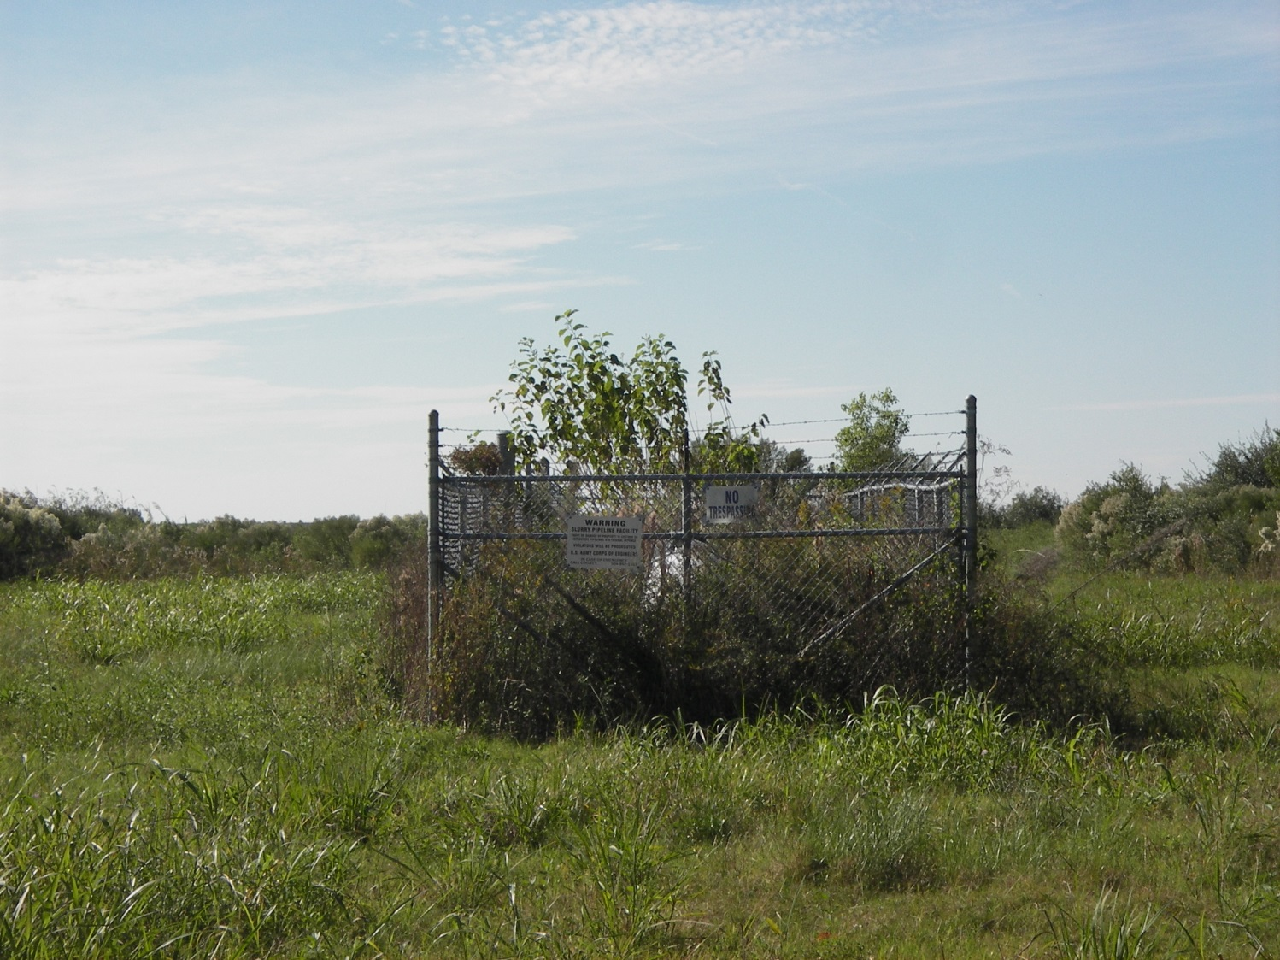
West Pumping Facility

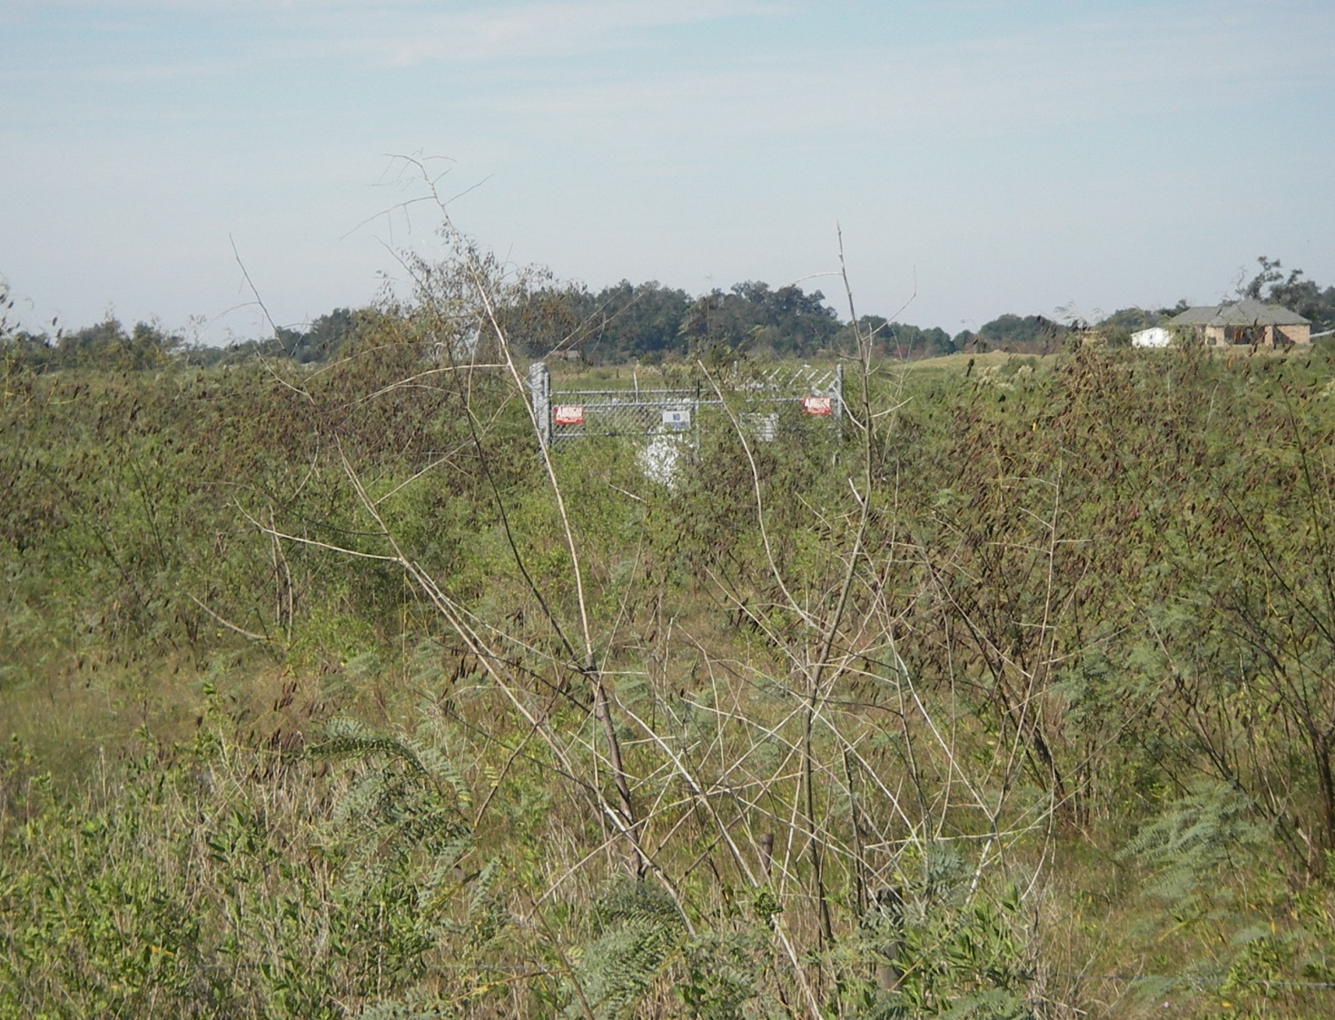
East Pumping Facility

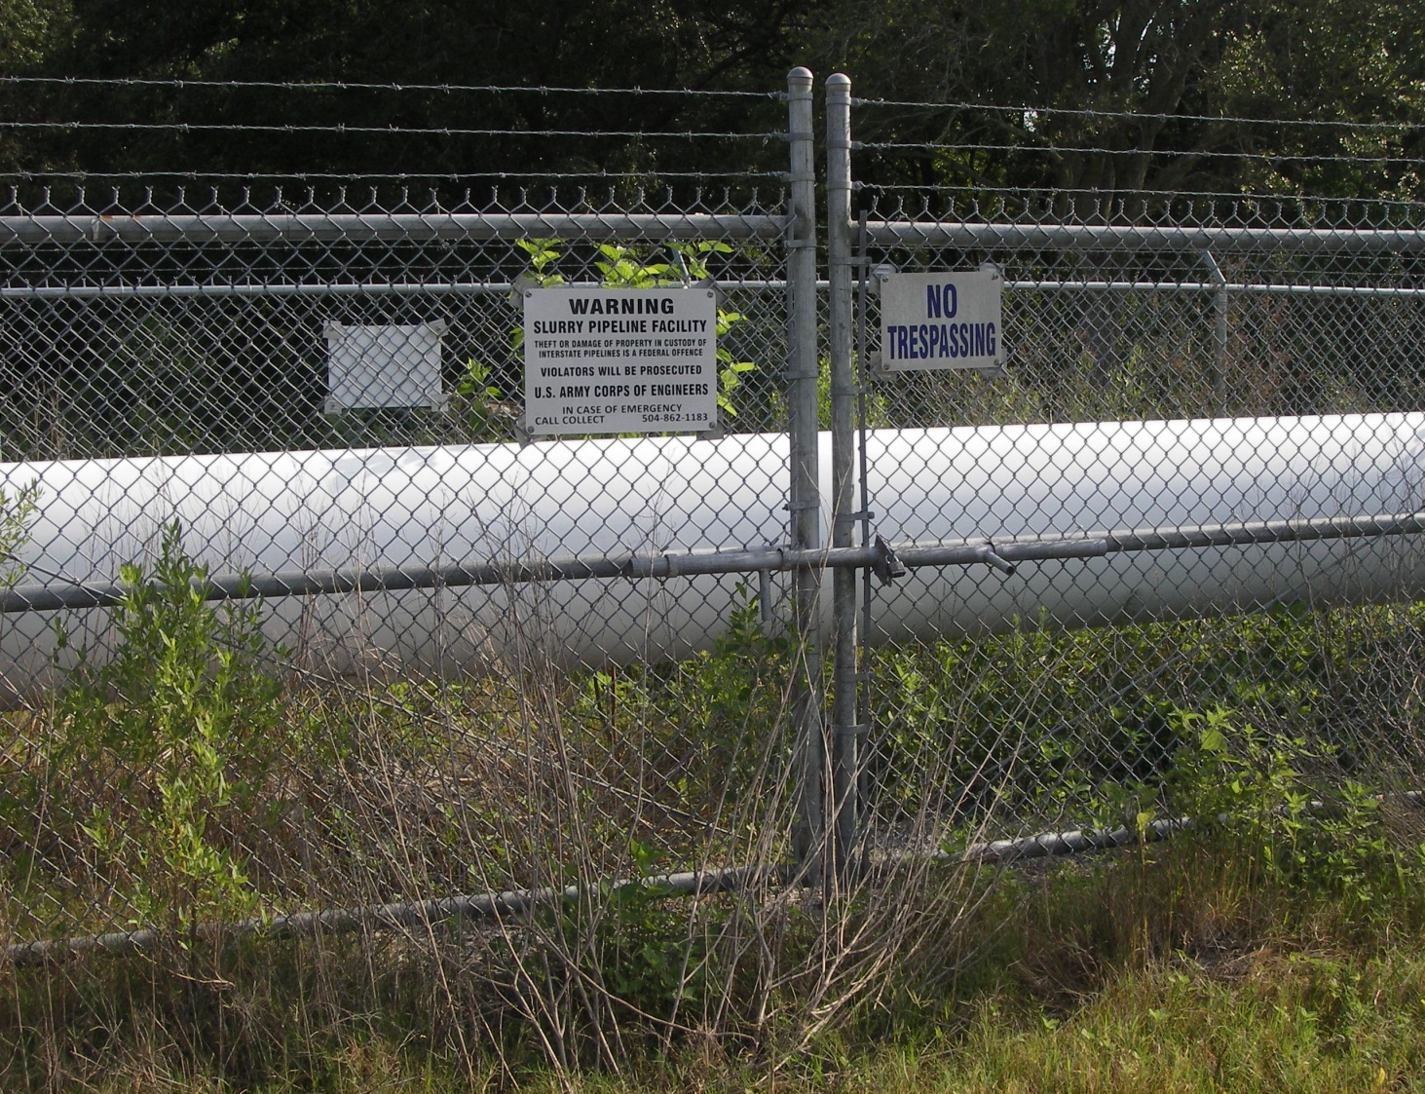
Double Gates

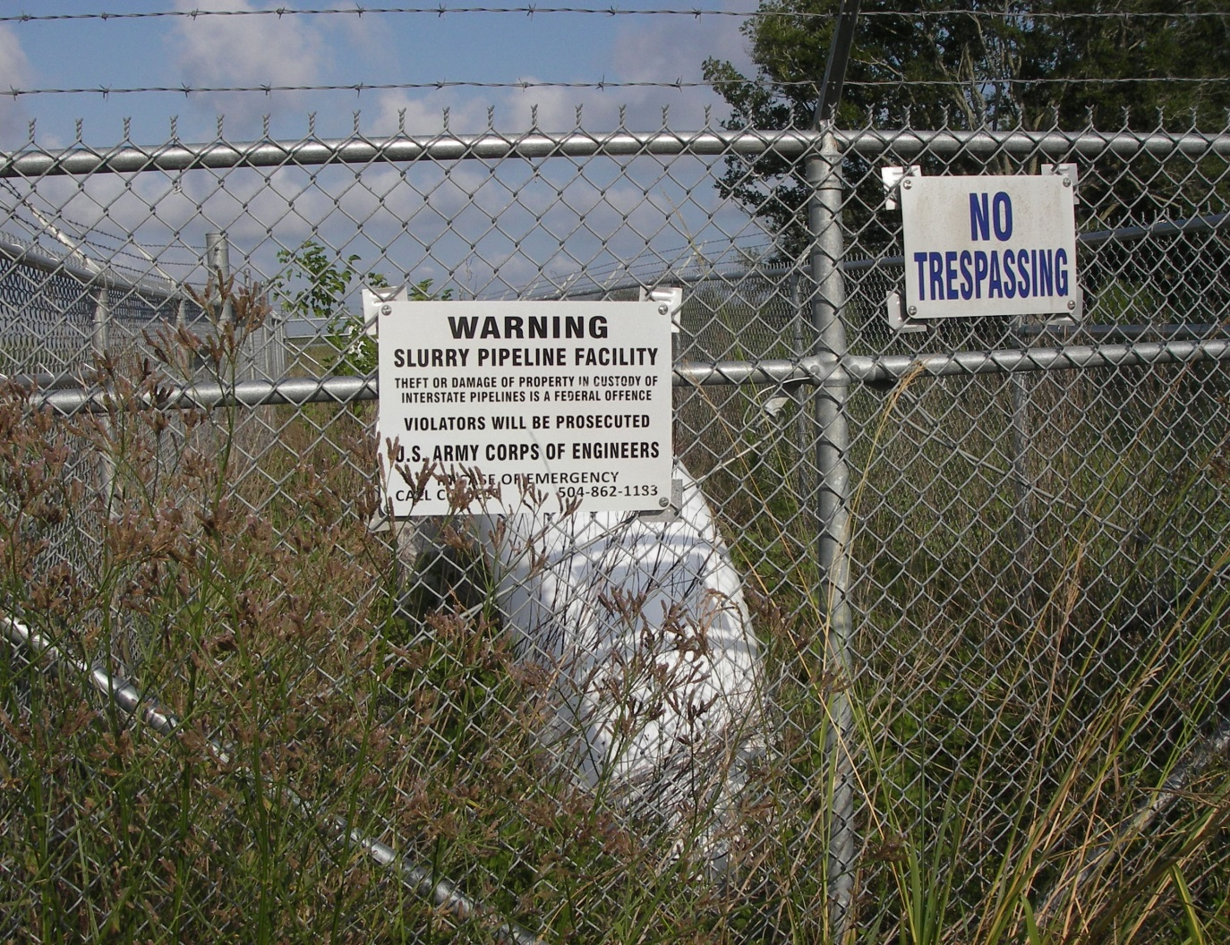
Typical Signage

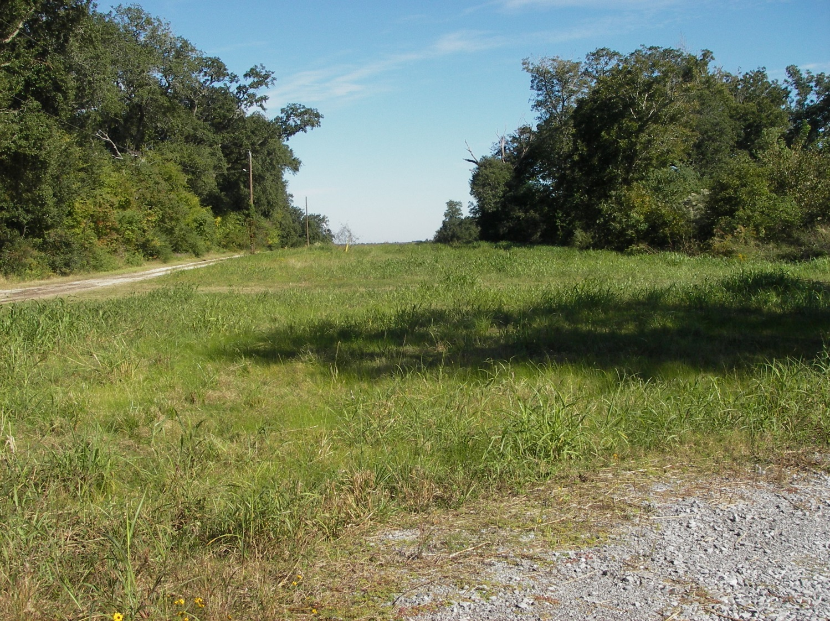
Pipeline Corridor (View from West Pumping Facility looking east)

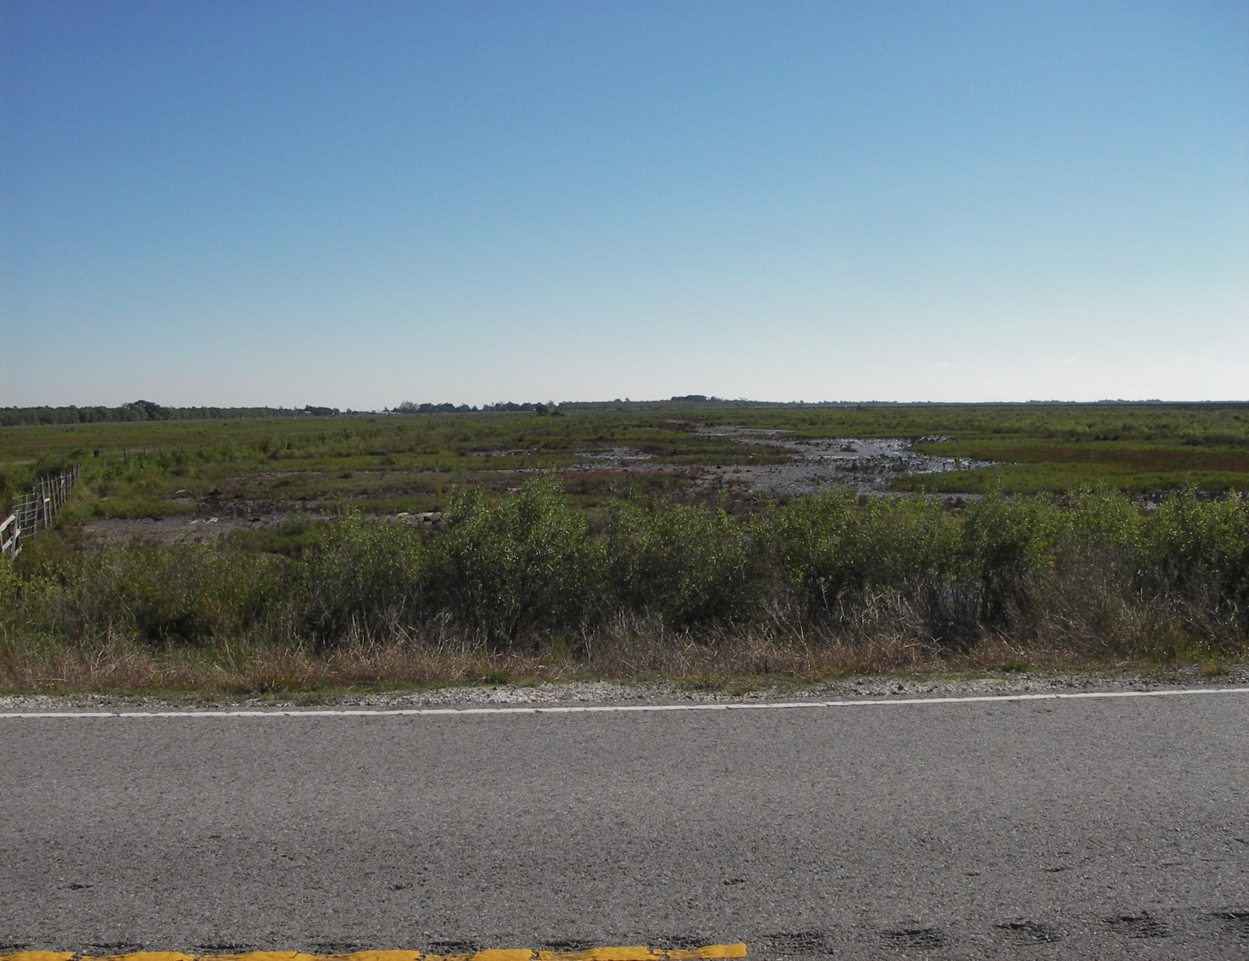
Pipeline Corridor (View from LA HWY 27 looking east)

Blind Flange Connections (Two Locations, West and East)

Each end of pipeline consists of a 29 inch inside diameter flanged pipe long radius elbow above ground with a blind flange connection.

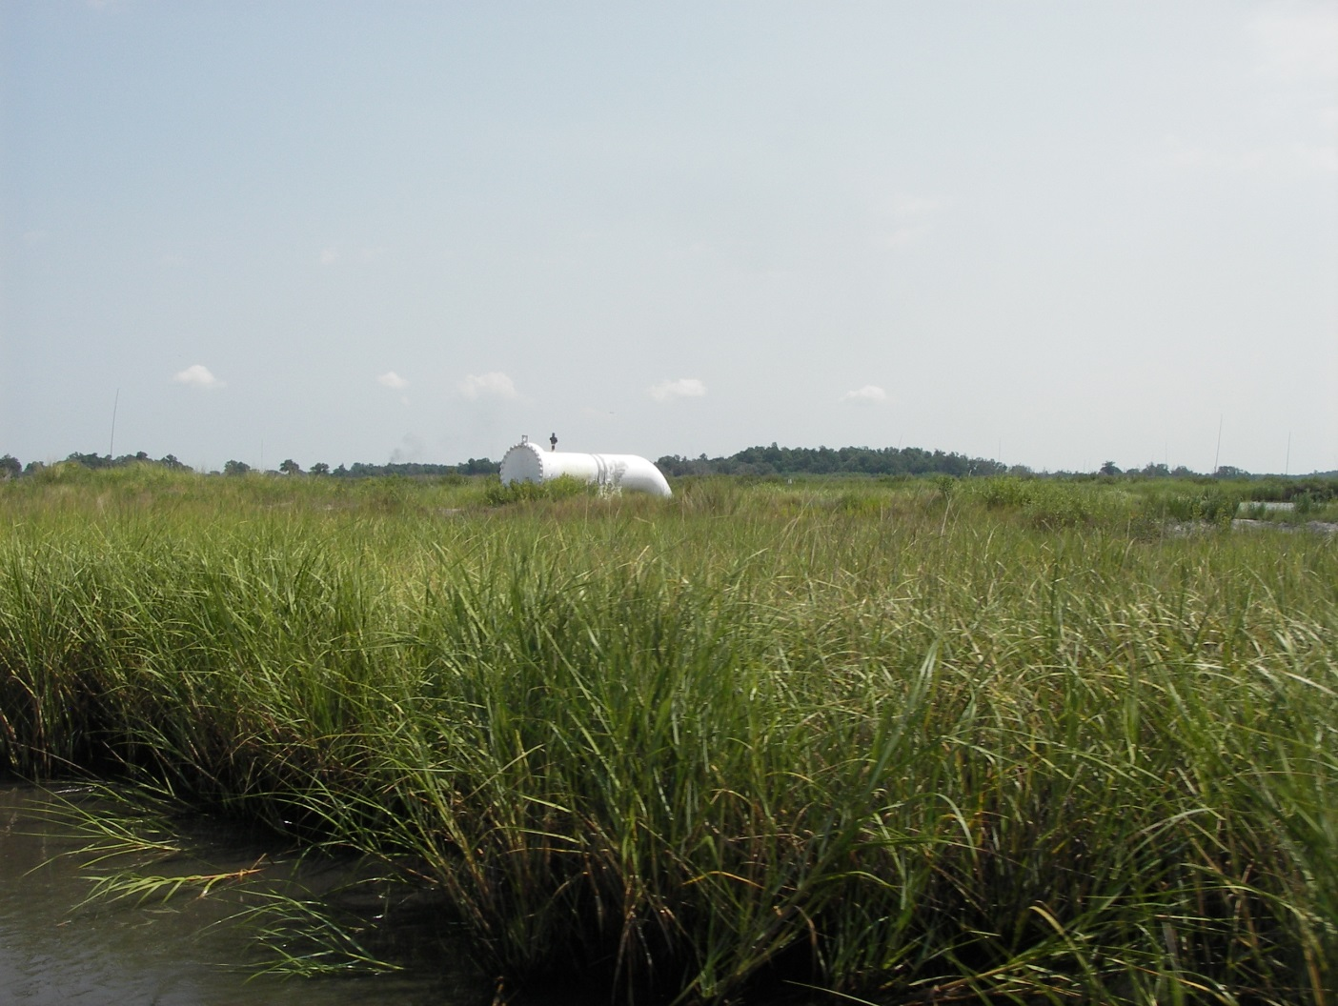
West End Blind Flange

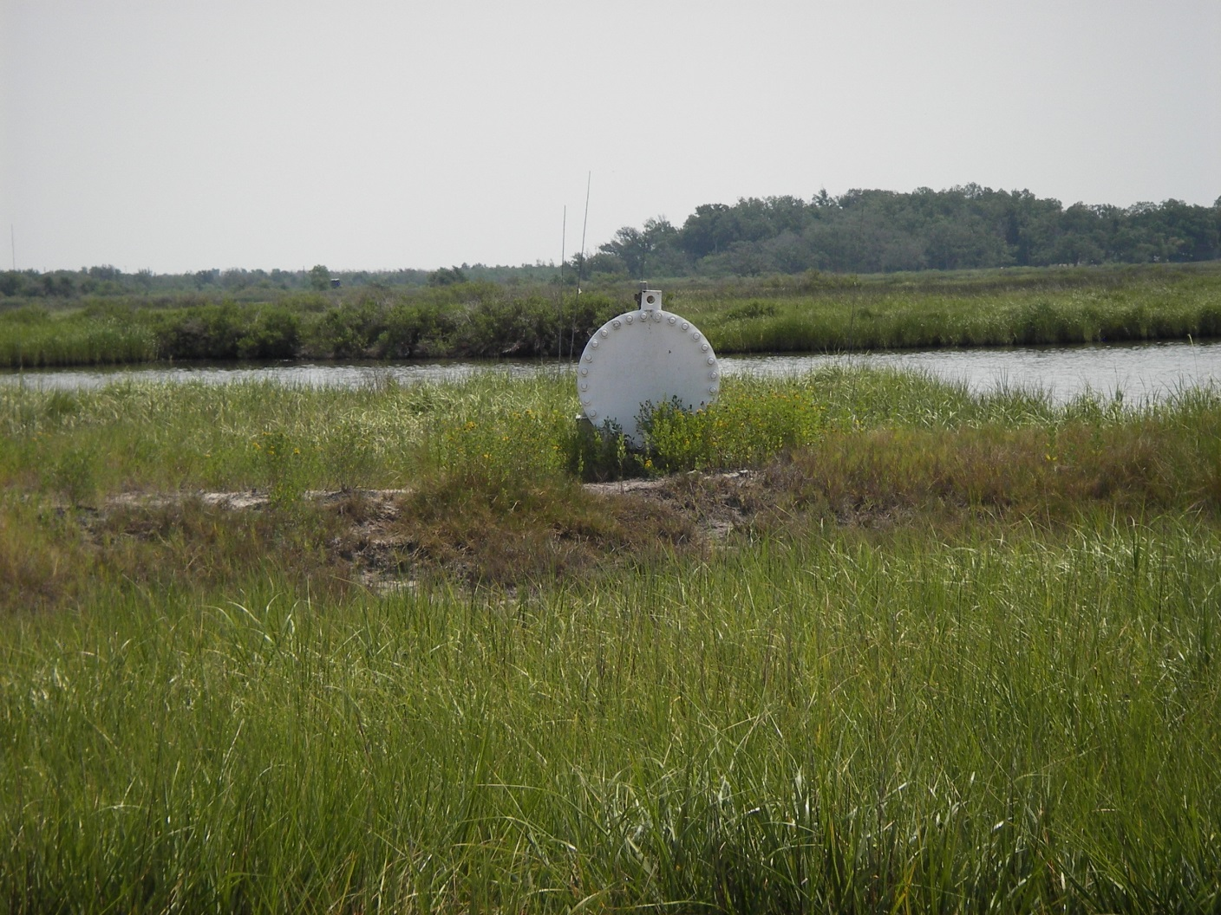
West End Blind Flange

