SPECIAL NOTICE

On Tuesday, September 9, 2014, the Office of Mineral Resources on behalf of the State Mineral and Energy Board advertised in the “The Notice of Publication” for receipt of sealed bids on or before noon on Tuesday, October 7, 2014 for State Leases and an Exclusive Geophysical Agreement Type 3 to be awarded upon Tracts 44076 through 44089, inclusive, at its October 8, 2014 Lease Sale. Within the said publication was an advertisement for Tract No. 44089, St. Mary Parish. By Virtue of this public notice, Tract No. 44089, (Exclusive Geophysical Agreement Type 3) St. Mary Parish is being removed from said October 8, 2014 Lease Sale and re-advertised and moved to the November 12, 2014 Sale as follows:

EXCLUSIVE GEOPHYSICAL AGREEMENT TRACT 44089 - St. Mary Parish, Louisiana
The Exclusive Geophysical Agreement is a Type 3, and carries a maximum Initial Term of Eighteen (18) months, with an Option Term, if exercised by additional payment as specified in the Agreement, of Six (6) months period. The Exclusive Geophysical Agreement #3, shall be effective from November 12, 2014 for a period terminating May 12, 2016, unless the Option period is activated by payment (timely) of the Option payment amount set forth in the Agreement, in which case the termination date shall be November 12, 2016, and which Agreement authorizes the successful bidder to conduct at least 3-D geophysical operations on all state owned water bottoms situated in St. Mary Parish, Louisiana, which area is identified for convenience as Tract #44089 and is more particularly described hereinafter, as follows: Beginning at a point having Coordinates of X = 1,940,272.60 and Y = 417,772.10; thence South 00 degrees 00 minutes 24 seconds East 35,426.31 feet to a point having Coordinates of X = 1,940,276.71 and Y = 382,345.79; thence South 88 degrees 22 minutes 03 seconds West 30,092.20 feet to a point having Coordinates of X = 1,910,196.73 and Y = 381,488.52; thence South 00 degrees 17 minutes 51 seconds West 1,555.36 feet to a point having Coordinates of X = 1,910,188.65 and Y = 379,933.18; thence South 83 degrees 47 minutes 24 seconds West 11,342.92 feet to a point having Coordinates of X = 1,898,912.29 and Y = 378,706.20; thence North 00 degrees 11 minutes 59 seconds West 5,798.41 feet to a point having Coordinates of X = 1,898,892.07 and Y = 384,504.57; thence North 18 degrees 38 minutes 26 seconds West 8,496.65 feet to a point having Coordinates of X = 1,896,176.28 and Y = 392,555.51; thence North 37 degrees 08 minutes 58 seconds West 8,760.96 feet to a point having Coordinates of X = 1,890,885.57 and Y = 399,538.53; thence North 00 degrees 02 minutes 32 seconds West 7,967.88 feet to a point having Coordinates of X = 1,890,879.70 and Y = 407,506.41; thence North 23 degrees 57 minutes 43 seconds East 3,842.41 feet to a point having Coordinates of X = 1,892,440.22 and Y = 411,017.66; thence South 89 degrees 59 minutes 59 seconds East 20,937.47 feet to a point having Coordinates of X = 1,913,377.68 and Y = 411,017.59; thence North 53 degrees 28 minutes 33 seconds East 9,875.92 feet to a point having Coordinates of X = 1,921,314.03 and Y = 416,895.36; thence North 87 degrees 21 minutes 08 seconds East 18,978.83 feet to the point of beginning, LESS AND EXCEPT any portion of State Lease No. 21014 and State Lease No. 18614 that may fall within the above described tract, and LESS AND EXCEPT any right, title, and interest in lands owned by and not under lease from the State of Louisiana, on behalf of the St. Mary Parish School Board, situated in Section 16, Township 15 South, Range 8 East, St. Mary Parish, Louisiana, contained within the above described tract, (This tract includes only waterbottoms claimed and owned by the state and specifically excludes any land which the state may claim or own and to which the mineral rights are vested in the state), containing approximately 4,732 acres, all as more particularly outlined on a plat on file in the Office of Mineral Resources, Department of Natural Resources. All bearings, distances and coordinates are based on the Louisiana Coordinate System of 1927, (North or South Zone), where applicable.

NOTE: The above description of the Tract nominated for an Exclusive Geophysical Agreement Type 3 and selected leases has been provided and corrected, where required, exclusively by the nomination party. Any mineral lease selected from this Tract and awarded by the Louisiana State Mineral and Energy Board shall be without warranty of any kind, either express, implied, or statutory, including, but not limited to, the implied warranties of merchantability and fitness for a particular purpose. Should the mineral lease awarded by the Louisiana State Mineral and Energy Board be subsequently modified, cancelled or abrogated due to the existence of conflicting leases, operating agreements, private claims or other future obligations or conditions which may affect all or any portion of the leased Tract, it shall not relieve the Lessee of the obligation to pay any bonus due thereon to the Louisiana State Mineral and Energy Board, nor shall the Louisiana State Mineral and Energy Board be obligated to refund any consideration paid by the Lessor prior to such modification, cancellation, or abrogation, including, but not limited to, bonuses, rentals and royalties.

The minimum bids which will be considered by the Mineral and Energy Board for the seismic survey portion of the agreement – (the seismic fee) shall be not less than $42.00 per acre for the initial 18 month term and one-half (1/2) of the seismic fee if the option is exercised. The minimum bids considered by the Mineral and Energy Board for leases selected under the agreement shall be not less than $600 per acre bonus, $300 per acre rental and 25% royalty. Successful bidder hereunder may select for lease up to the entire amount of presently unleased state-owned lands and water bottoms within the Tract for a primary term of three (3) years at the bid bonus/rental and royalty. All operations conducted under the agreement by the successful bidder, including leasing operations for leases selected thereunder, shall be conducted in accordance with policy of the State Mineral and Energy Board as enunciated in the agreement and which is on file in the Office of Mineral Resources. Copies of same may be obtained upon request.

A cashier’s check, certified check or bank money order, payable to the Office of Mineral Resources for the full amount of cash consideration (but not less than $42.00 per acre) offered for the Exclusive Geophysical Agreement Type 3 on said Tract shall accompany and be deposited with the bid. No portion bids will be accepted. The State Mineral and Energy Board reserves the right to reject any and all bids.

Additional Consideration: Energy XXI Onshore, LLC will deliver to the appropriate State of Louisiana Agency (within ninety days of its delivery to Energy XXI Onshore, LLC), a copy of any 3-D data so acquired as it covers and affects lands subject to the Exclusive Geophysical Agreement. This additional consideration will be contingent upon the State maintaining the data submitted in a confidential fashion and in accordance with the pertinent Licensing Agreement affecting such data.

There shall be a liquidated damage payment equal to the seismic fee for failure to conduct the Geophysical Survey.

NOTE: The State of Louisiana does hereby reserve, and this Exclusive Geophysical Agreement Type 3 and selected leases shall be subject to, the imprescriptible right of surface use in the nature of a servitude in favor of the Department of Natural Resources, including its Offices and Commissions, for the sole purpose of implementing, constructing, servicing and maintaining approved coastal zone management and/or restoration projects. Utilization of any and all rights derived under this Exclusive Geophysical Agreement Type 3 and selected leases by the mineral lessee, its agents, successors or assigns, shall not interfere with nor hinder the reasonable surface use by the Department of Natural Resources, its Offices or Commissions, as herein above reserved.

NOTE: This tract is located in an area designated by the Louisiana Legislature or the Wildlife and Fisheries Commission as a Public Oyster Seed Ground or Reservation. Surface activity within the boundaries of these designated Public Oyster Seed Grounds or Reservations is prohibited.
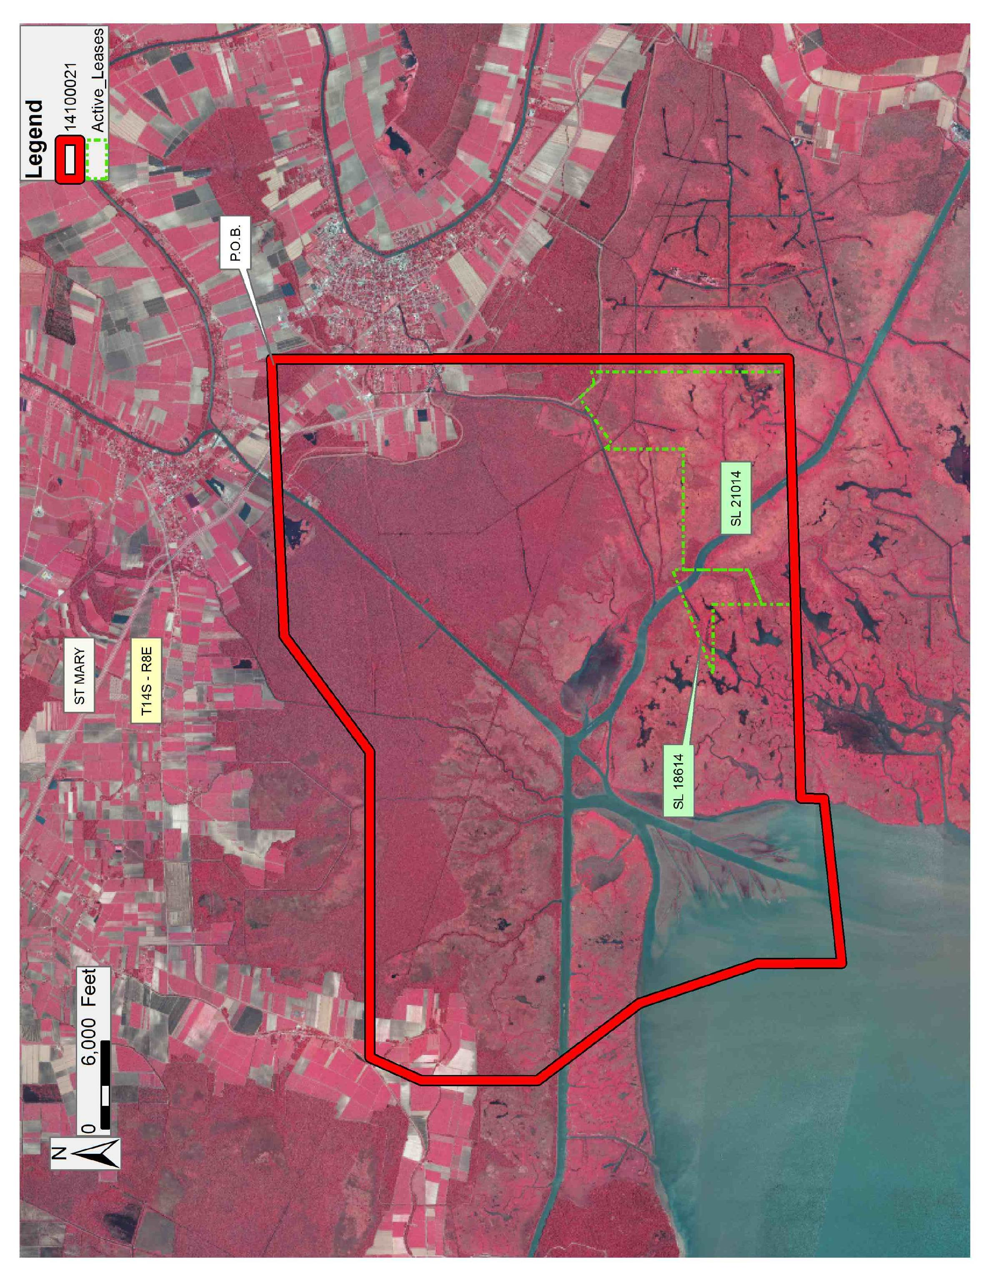
Office of Mineral Resources, Acres: 4732 Tract Number: 44089

