SPECIAL NOTICE

On Tuesday, August 14, 2018, the Office of Mineral Resources on behalf of the State Mineral and Energy Board advertised in the “The Notice of Publication” for receipt of sealed bids on or before 12:00 noon on Tuesday, September 11, 2018 for State Leases to be awarded upon Tracts 44961 through 44982, inclusive, at its September 12, 2018 Lease Sale. By Virtue of this public notice, Inland Tract No. 44979 through 44982, Jefferson Parish, Louisiana were advertised with incorrect language. They are hereby corrected as follows:

TRACT 44979 - Iberia Parish School Board - Iberia Parish, Louisiana
The State Mineral and Energy Board acting on behalf of the Iberia Parish School Board, pursuant to Resolution(s) adopted by that (those) body(ies) and in accordance with Louisiana Revised Statutes 30:121-136 and 151-156, as amended, and Article XIV, Section 16(A)(9) and (B) of the Louisiana Constitution of 1974, as same may be continued and promulgated in proper statutory form and, further, amended from time to time, advertises the lands not under mineral lease on September 12, 2018, excluding the beds and bottoms of all navigable water bodies located within the following: All of Fractional Section 16, Township 12 South, Range 10 East in Iberia Parish, Louisiana, containing approximately 298.12 acres, all as more particularly outlined on a plat on file in the Office of Mineral Resources, Department of Natural Resources. All bearings, distances and coordinates are based on Louisiana Coordinate System of 1927, (North or South Zone).

NOTE: The above description of the Tract nominated for lease has been provided and corrected, where required, exclusively by the nomination party. Any mineral lease selected from this Tract and awarded by the Louisiana State Mineral and Energy Board shall be without warranty of any kind, either express, implied, or statutory, including, but not limited to, the implied warranties of merchantability and fitness for a particular purpose. Should the mineral lease awarded by the Louisiana State Mineral and Energy Board be subsequently modified, cancelled or abrogated due to the existence of conflicting leases, operating agreements, private claims or other future obligations or conditions which may affect all or any portion of the leased Tract, it shall not relieve the Lessee of the obligation to pay any bonus due thereon to the Louisiana State Mineral and Energy Board, nor shall the Louisiana State Mineral and Energy Board be obligated to refund any consideration paid by the Lessor prior to such modification, cancellation, or abrogation, including, but not limited to, bonuses, rentals and royalties.

NOTE: This acreage is entirely within the boundary of the Atchafalaya Basin Legal Area.
Applicant: MIIA EXPLORATION to Agency and by Resolution from the Iberia Parish School Board authorizing the Mineral Board to act in its behalf

Bidder | Cash Payment | Price/ Acre | Rental | Oil | Gas | Other

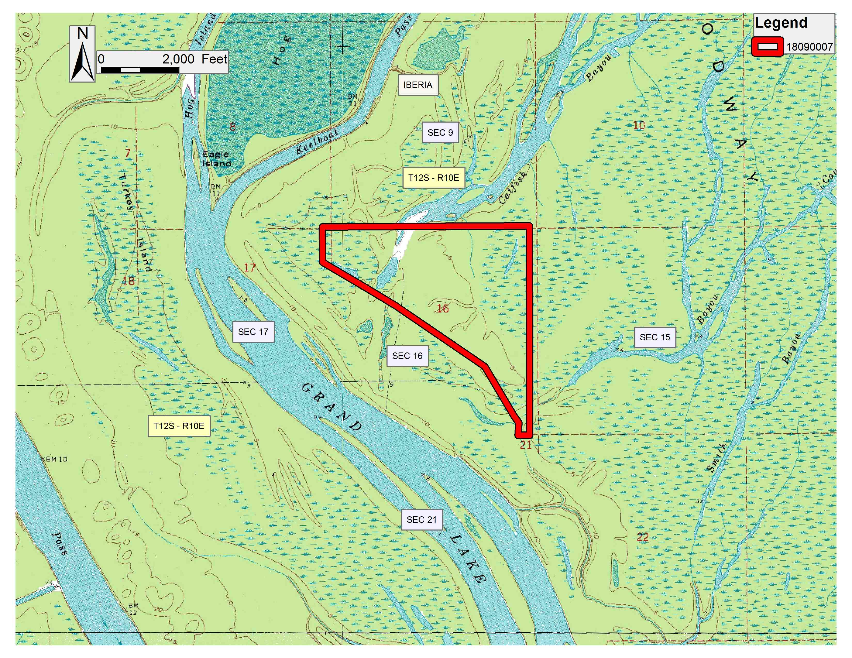
Office of Mineral Resources, Acres: 298.12 Tract Number: 44979

TRACT 44980 - Iberia Parish School Board - Iberia Parish, Louisiana
The State Mineral and Energy Board acting on behalf of the Iberia Parish School Board, pursuant to Resolution(s) adopted by that (those) body(ies) and in accordance with Louisiana Revised Statutes 30:121-136 and 151-156, as amended, and Article XIV, Section 16(A)(9) and (B) of the Louisiana Constitution of 1974, as same may be continued and promulgated in proper statutory form and, further, amended from time to time, advertises the lands not under mineral lease on September 12, 2018, excluding the beds and bottoms of all navigable water bodies located within the following: All of Fractional Section 16, Township 12 South, Range 8 East in Iberia Parish, Louisiana, containing approximately 426.42 acres, all as more particularly outlined on a plat on file in the Office of Mineral Resources, Department of Natural Resources. All bearings, distances and coordinates are based on Louisiana Coordinate System of 1927, (North or South Zone).

NOTE: The above description of the Tract nominated for lease has been provided and corrected, where required, exclusively by the nomination party. Any mineral lease selected from this Tract and awarded by the Louisiana State Mineral and Energy Board shall be without warranty of any kind, either express, implied, or statutory, including, but not limited to, the implied warranties of merchantability and fitness for a particular purpose. Should the mineral lease awarded by the Louisiana State Mineral and Energy Board be subsequently modified, cancelled or abrogated due to the existence of conflicting leases, operating agreements, private claims or other future obligations or conditions which may affect all or any portion of the leased Tract, it shall not relieve the Lessee of the obligation to pay any bonus due thereon to the Louisiana State Mineral and Energy Board, nor shall the Louisiana State Mineral and Energy Board be obligated to refund any consideration paid by the Lessor prior to such modification, cancellation, or abrogation, including, but not limited to, bonuses, rentals and royalties.

Applicant: MIIA EXPLORATION to Agency and by Resolution from the Iberia Parish School Board authorizing the Mineral Board to act in its behalf

Bidder | Cash Payment | Price/ Acre | Rental | Oil | Gas | Other

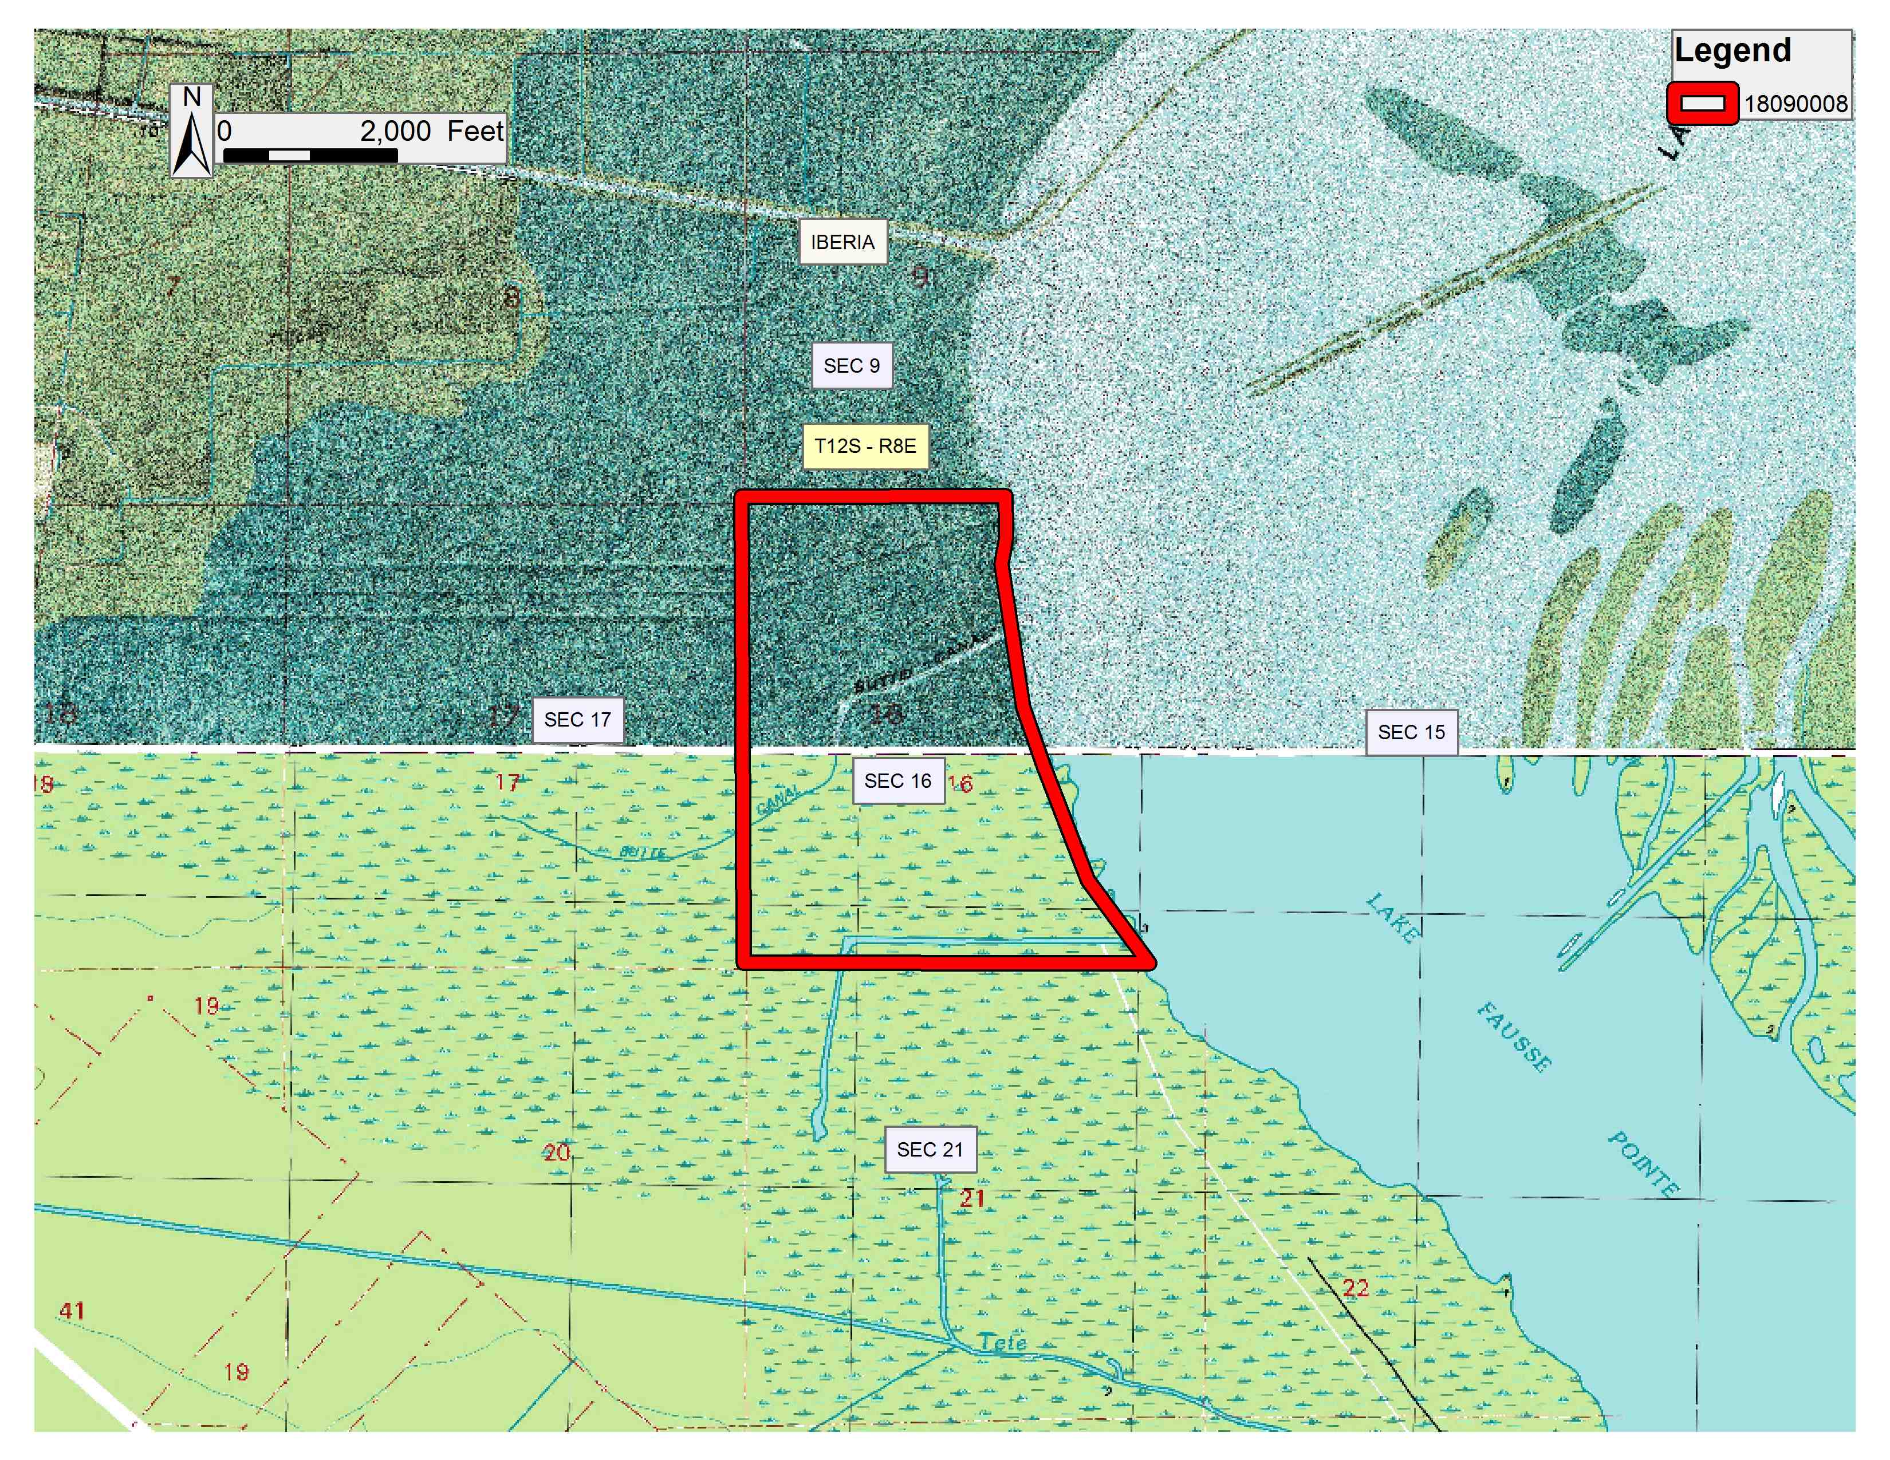
Office of Mineral Resources, Acres: 426.42 Tract Number: 44980

TRACT 44981 - Iberia Parish School Board - Iberia Parish, Louisiana
The State Mineral and Energy Board acting on behalf of the Iberia Parish School Board, pursuant to Resolution(s) adopted by that (those) body(ies) and in accordance with Louisiana Revised Statutes 30:121-136 and 151-156, as amended, and Article XIV, Section 16(A)(9) and (B) of the Louisiana Constitution of 1974, as same may be continued and promulgated in proper statutory form and, further, amended from time to time, advertises the lands not under mineral lease on September 12, 2018, excluding the beds and bottoms of all navigable water bodies located within the following: All of Section 16, Township 17 South, Range 5 East in Iberia Parish, Louisiana, containing approximately 640.20 acres, all as more particularly outlined on a plat on file in the Office of Mineral Resources, Department of Natural Resources. All bearings, distances and coordinates are based on Louisiana Coordinate System of 1927, (North or South Zone).

NOTE: The above description of the Tract nominated for lease has been provided and corrected, where required, exclusively by the nomination party. Any mineral lease selected from this Tract and awarded by the Louisiana State Mineral and Energy Board shall be without warranty of any kind, either express, implied, or statutory, including, but not limited to, the implied warranties of merchantability and fitness for a particular purpose. Should the mineral lease awarded by the Louisiana State Mineral and Energy Board be subsequently modified, cancelled or abrogated due to the existence of conflicting leases, operating agreements, private claims or other future obligations or conditions which may affect all or any portion of the leased Tract, it shall not relieve the Lessee of the obligation to pay any bonus due thereon to the Louisiana State Mineral and Energy Board, nor shall the Louisiana State Mineral and Energy Board be obligated to refund any consideration paid by the Lessor prior to such modification, cancellation, or abrogation, including, but not limited to, bonuses, rentals and royalties.

NOTE: This tract is located within the Marsh Island Wildlife Refuge under the jurisdiction of the Louisiana Department of Wildlife and Fisheries which has promulgated rules and regulations for the protection of game and wildlife on the aforesaid Tract and, therefore, shall be subject to said rules and regulations, a copy of which may be obtained from the Department of Wildlife and Fisheries. In addition to the specific rules and regulations applicable, the following shall apply regarding operations under this mineral lease:

1. Compliance with provisions and conditions governing drilling and production operations on Marsh Island (conditions 1-22) and general provisions governing both geophysical exploration and drilling and production operations on Marsh Island (conditions 1-11) shall be required. The provisions and conditions shall be attached to the mineral lease. Contact Kyle Balkum at (225)765-2819 for information on the provisions and conditions.
Applicant: MIIA EXPLORATION to Agency and by Resolution from the Iberia Parish School Board authorizing the Mineral Board to act in its behalf

Bidder | Cash Payment | Price/ Acre | Rental | Oil | Gas | Other

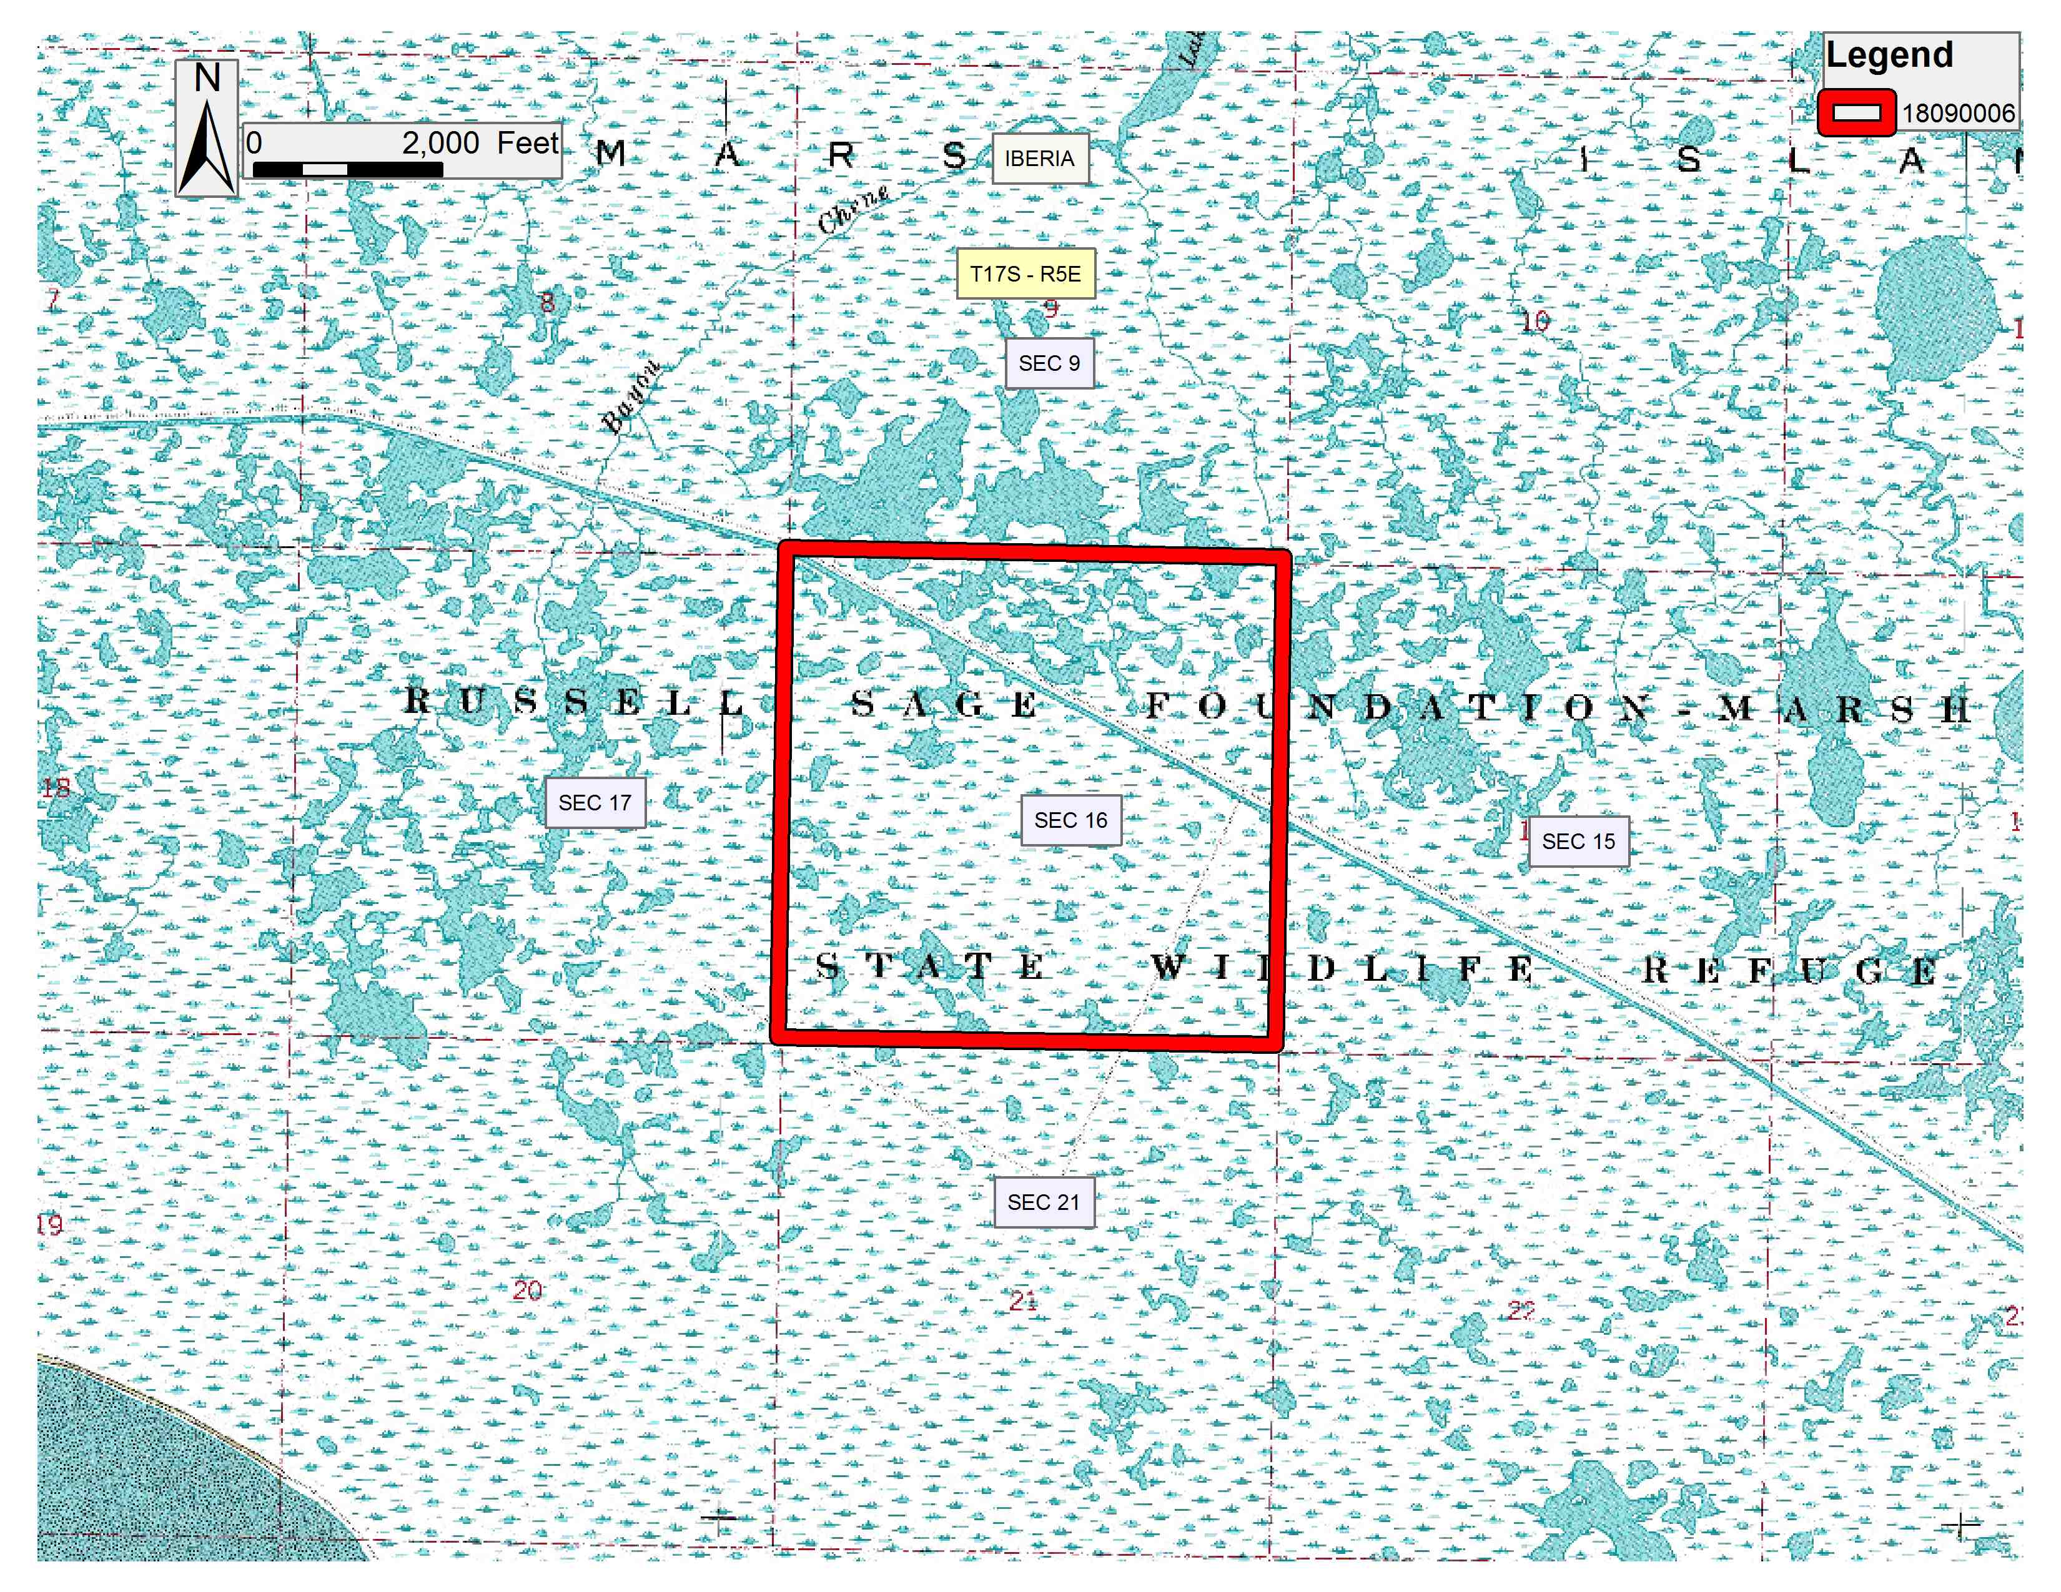
Office of Mineral Resources, Acres: 640.2 Tract Number: 44981

TRACT 44982 - Iberia Parish School Board - Iberia Parish, Louisiana
The State Mineral and Energy Board acting on behalf of the Iberia Parish School Board, pursuant to Resolution(s) adopted by that (those) body(ies) and in accordance with Louisiana Revised Statutes 30:121-136 and 151-156, as amended, and Article XIV, Section 16(A)(9) and (B) of the Louisiana Constitution of 1974, as same may be continued and promulgated in proper statutory form and, further, amended from time to time, advertises the lands not under mineral lease on September 12, 2018, excluding the beds and bottoms of all navigable water bodies located within the following: All of Section 16, Township 17 South, Range 6 East in Iberia Parish, Louisiana, containing approximately 640.68 acres, all as more particularly outlined on a plat on file in the Office of Mineral Resources, Department of Natural Resources. All bearings, distances and coordinates are based on Louisiana Coordinate System of 1927, (North or South Zone).

NOTE: The above description of the Tract nominated for lease has been provided and corrected, where required, exclusively by the nomination party. Any mineral lease selected from this Tract and awarded by the Louisiana State Mineral and Energy Board shall be without warranty of any kind, either express, implied, or statutory, including, but not limited to, the implied warranties of merchantability and fitness for a particular purpose. Should the mineral lease awarded by the Louisiana State Mineral and Energy Board be subsequently modified, cancelled or abrogated due to the existence of conflicting leases, operating agreements, private claims or other future obligations or conditions which may affect all or any portion of the leased Tract, it shall not relieve the Lessee of the obligation to pay any bonus due thereon to the Louisiana State Mineral and Energy Board, nor shall the Louisiana State Mineral and Energy Board be obligated to refund any consideration paid by the Lessor prior to such modification, cancellation, or abrogation, including, but not limited to, bonuses, rentals and royalties.

NOTE: This tract is located within the Marsh Island Wildlife Refuge under the jurisdiction of the Louisiana Department of Wildlife and Fisheries which has promulgated rules and regulations for the protection of game and wildlife on the aforesaid Tract and, therefore, shall be subject to said rules and regulations, a copy of which may be obtained from the Department of Wildlife and Fisheries. In addition to the specific rules and regulations applicable, the following shall apply regarding operations under this mineral lease:

1. Compliance with provisions and conditions governing drilling and production operations on Marsh Island (conditions 1-22) and general provisions governing both geophysical exploration and drilling and production operations on Marsh Island (conditions 1-11) shall be required. The provisions and conditions shall be attached to the mineral lease. Contact Kyle Balkum at (225)765-2819 for information on the provisions and conditions.
Applicant: MIIA EXPLORATION to Agency and by Resolution from the Iberia Parish School Board authorizing the Mineral Board to act in its behalf

Bidder | Cash Payment | Price/ Acre | Rental | Oil | Gas | Other

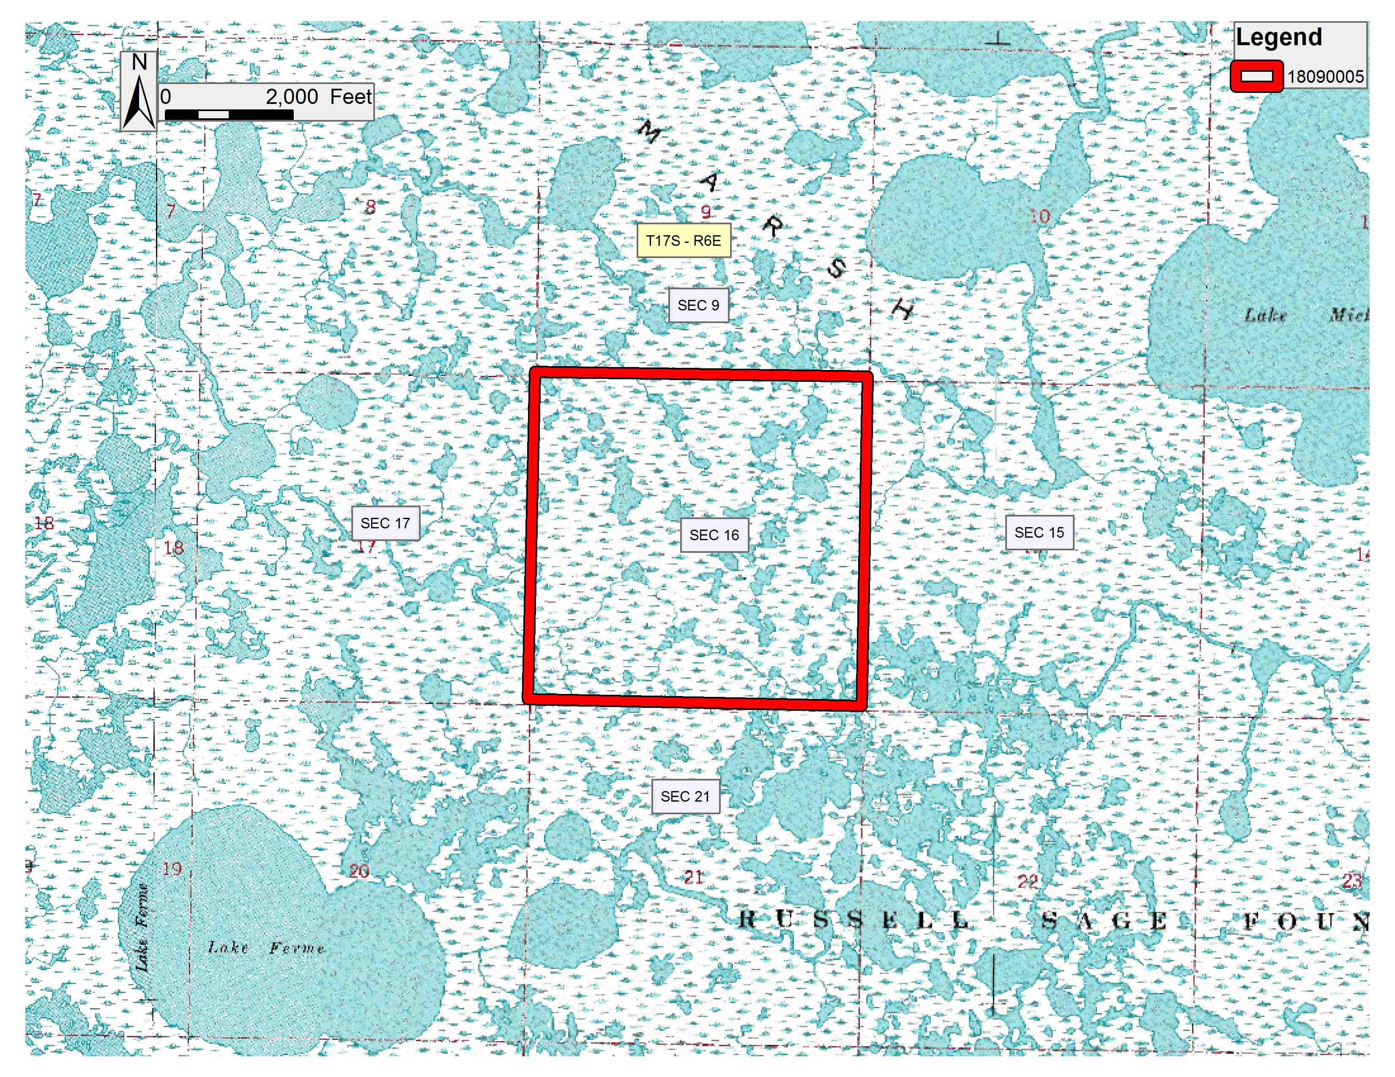
Office of Mineral Resources, Acres: 640.68 Tract Number: 44982

