

**June 2013 Funding as of 6/30/13 - Final**

## Program Overview

As part of the American Recovery and Reinvestment Act (ARRA) of 2009, the Louisiana Department of Natural Resources (LDNR) was awarded $71.7 million through the State Energy Program (SEP) Grant. The SEP grant dollars were allocated toward six programs, including the ENERGY STAR® Appliance Rebate, Home Energy Rebate Option (HERO), Renewable Energy, State Buildings–Lead By Example, Transportation Efficiency & Alternative Fuels Programs, and the Revolving Loan Fund. An additional $4.2 million was awarded through the ARRA ENERGY STAR® Appliance Rebate Grant and $13.8 million was awarded through the Energy Efficiency Conservation Block Grant Program (EECBG). LDNR developed a diverse portfolio of programs to maximize energy efficiency, renewable energy, and alternative transportation opportunities. These programs target the residential, commercial, and public sectors in an effort to distribute the funds throughout Louisiana.

**Benefit to Louisiana:** Increased energy efficiency to reduce energy costs and consumption; reduced reliance on imported energy; improved reliability of electricity and fuel supply and the delivery of energy services; reduced impacts of energy production and use on the environment.

|  |  |
| --- | --- |
| **Total Project Funding:** | $80,854,982 |
| **Expended:** | $80,854,982 |
| **Remaining:** | $0 |
| **Total Projects Completed:** | 3,571 |
| **Total Jobs Created/Saved:** | 367 |
| **Total Indirect&Induced Jobs:** | 1,635 |
| **Total Energy Saved/Created** | 890,294 mmBTU |
| **LDNR Program Manager:** | Paula Ridgeway |



|  |  |
| --- | --- |
| **Total Project Funding:** | $80,854,982 |
| **Education, Training, and Outreach Program:** | $1,348,593 |
| **Total Administrative Fees:**  Shaw:  IEM:  LDNR: | $7,487,006 $3,927,542  $1,333,182  $2,226,282 |
| **Total Funding:** | $89,690,582 |
| **LDNR Program Manager:** | Tangular Jones |

**Deadline for Spending the 2009 ARRA Funds:**

* Funds appropriated under the Recovery Act are available for Federal reimbursement of costs until September 15, 2015. However, the period of performance awarded by DOE required an ending date of April 30, 2012. DOE eventually allowed states to extend this period and Louisiana extended the period of performance to December 31, 2012. Each program had a specified project completion deadline (these deadlines varied from February through December 2012).

|  |  |  |  |
| --- | --- | --- | --- |
| **Program Award** | **Total Funding** | **Total Spent** | **Spent %** |
|  | | | |
| **State Energy Program Award Funding** | | | |
| HERO Program Funding | $7,926,969 | $7,926,969 | 100% |
| State Buildings Program Funding | $24,454,925 | $24,454,925 | 100% |
| Renewables Funding | $9,814,462 | $9,814,462 | 100% |
| Transportation Program Funding | $7,781,271 | $7,781,271 | 100% |
| ENERGY STAR SEP Program Funding | $1,716,100 | $1,716,100 | 100% |
| Revolving Loan Fund | $12,725,382 | $12,725,382 | 100% |
| Education, Training, Dissemination | $1,348,593 | $1,348,593 | 100% |
| Administrative Funding | $5,927,017 | $5,927,017 | 100% |
| **TOTAL State Energy Program Award Funding** | **$71,694,718** | **$71,694,718** | **100%** |
|  | | | |
| **EECBG Award Funding** | | | |
| EECBG Program Funding | $12,626,925 | $12,626,925 | 100% |
| Administrative Funding | $1,136,968 | $1,136,968 | 100% |
| **TOTAL EECBG Award Funding** | **$13,763,893** | **$13,763,893** | 100% |
|  | | | |
| **ENERGY STAR Add'l Grant Award Funding** | | | |
| ENERGY STAR Additional Grant Funding | $3,808,950 | $3,808,950 | 100% |
| Administrative Funding | $423,021 | $423,021 | 100% |
| **TOTAL ENERGY STAR Add'l Grant Award Funding** | **$4,231,971** | **$4,231,971** | **100%** |
|  | | | |
| **ENERGY PROGRAMS AWARDS GRAND TOTALS** | **$89,690,582** | **$89,690,582** | **100%** |

In 2012, LDNR placed special emphasis on ensuring that all projects were completed, all remaining invoices payed, and all programs were in compliance with all rules and regulations established by DOE, OMB, as well as recommendations by Legislative Auditors.

Additionally, LDNR expanded the established Revolving Loan Fund to provide a mechanism to continue funding Louisiana energy efficiency and renewable energy projects after the ARRA grant expires, while maintaining ARRA requirements in perpetuity.

Details about individual programs are included in this final Executive Briefing below.

## ENERGY STAR® Appliance Rebate Program

This program was designed to encourage the purchase of ENERGY STAR® appliances.

**Benefit to Louisiana:** Increased energy efficiency to reduce energy costs and consumption; reduced reliance on imported energy

|  |  |  |  |
| --- | --- | --- | --- |
|  | **SEP** | **Additional Grant** | **Total** |
| **Funding Amount:** | $1,716,100 | $3,808,950 | $5,525,050 |
| **Expended** | $1,716,100 | $3,808,950 | $5,525,050 |
| **Remaining:** | $0 | $0 | $0 |
| **Rebates Issued:** | 27,322 | | |
| **LDNR Program Manager:** | Louis McArthur | | |

**Deadline for Program:**

* August 20, 2011

**Milestones Accomplished:**

* All paperwork received, payments made, auditing functions complete, and closeout reporting to DOE.

Table - Distribution of Purchased Appliances and Associated Energy Savings For ENERGY STAR®

|  |  |  |  |
| --- | --- | --- | --- |
| **Equipment** | **Number of Purchased Units** | **Energy Savings (mmBTU)** | **Energy Savings (Percentage)** |
| **Central Air Conditioners** | 1,744 | 9,544 | 25.10% |
| **Gas Tankless Water Heaters** | 160 | 6,400 | 16.83% |
| **Refrigerators** | 10,110 | 4,729 | 12.43% |
| **Clothes Washers** | 5,326 | 4,045 | 10.64% |
| **Gas Storage Water Heaters** | 370 | 3,700 | 9.73% |
| **Furnaces** | 292 | 2,920 | 7.68% |
| **Air Source Heat Pumps** | 303 | 2,672 | 7.03% |
| **Dishwashers** | 7,133 | 2,463 | 6.48% |
| **Room Air Conditioners** | 1,128 | 608 | 1.60% |
| **Electric Heat Pump Water Heaters** | 57 | 489 | 1.29% |
| **Freezers** | 694 | 300 | 0.79% |
| **Solar Water Heater (Electric Backup)** | 2 | 131 | 0.34% |
| **Solar Water Heaters (Gas Backup)** | 3 | 30 | 0.08% |
| **Total** | **27,322** | **38,031** | **100%** |

## State Buildings Lead By Example

LDNR created the State Buildings–Lead by Example Program to encourage the development, implementation, and deployment of cost-effective, energy-efficient projects in Louisiana State Buildings, and to support the creation of additional employment opportunities and other economic development benefits.

**Benefit to Louisiana:** Increased energy efficiency to reduce energy costs and consumption; reduced reliance on imported energy.

|  |  |
| --- | --- |
| **Funding Amount:** | $24,454,925 |
| **Expended:** | $24,454,925 |
| **Remaining:** | $0 |
| **Projects Completed:** | 33 |
| **LDNR Program Manager:** | Louis McArthur |

**Administrative Steps Taken:**

* January 18, 2012, sent urgent deadline reminder and reporting requirements letter subgrantees.

**Milestones Accomplished:**

* All projects completed within the amended performance period.

Table - Energy Savings and GHG Emission Reduction for State Buildings Projects

|  |  |  |  |  |
| --- | --- | --- | --- | --- |
| **University** | **Funding Amount** | **Managing Entity** | **Energy Savings (mmBTU)** | **GHG Emission Reduction (MTCO2E)** |
| **LCTCS - Final/All Projects** | $2,357,086 | State Buildings - IAG | 10,054.59 | 1,571.23 |
| **LSU A&M** | $1,156,729 | State Buildings - IAG | 57,708.80 | 9,018.15 |
| **LSU Alexandria** | $96,370 | State Buildings - IAG | 127.49 | 19.92 |
| **LSU Eunice** | $901,192 | State Buildings - IAG | 654.06 | 102.21 |
| **LSU HSC New Orleans** | $175,307 | State Buildings - IAG | 6,604.52 | 1,032.09 |
| **LSU HSC Shreveport** | $125,400 | State Buildings - IAG | 0.20 | 0.03 |
| **LSU Law Center** | $240,899 | State Buildings - IAG | 1,490.02 | 282.85 |
| **LSU Pennington** | $221,878 | State Buildings - IAG | 227.90 | 35.61 |
| **LSU Shreveport** | $320,930 | State Buildings - IAG | 1,017.75 | 159.04 |
| **LUMCON** | $33,651 | State Buildings - IAG | 303.13 | 47.37 |
| **McNeese State University** | $355,480 | State Buildings - IAG | 1,386.21 | 216.62 |
| **Nicholls** | $335,370 | State Buildings - IAG | 389.89 | 60.93 |
| **Northwestern State University** | $796,063 | State Buildings - IAG | 952.74 | 148.88 |
| **Southern University A&M** | $344,087 | State Buildings - IAG | 222.08 | 34.70 |
| **Southern University New Orleans** | $460,472 | State Buildings - IAG | 3.02 | 0.47 |
| **Southern University Shreveport** | $167,319 | State Buildings - IAG | 90.21 | 14.10 |
| **University of Louisiana Monroe** | $990,728 | State Buildings - IAG | 8,923.51 | 1,394.48 |
| **Grambling State University** | $793,163 | State Buildings - OFP | 939.85 | 146.87 |
| **LA Tech** | $1,605,382 | State Buildings - OFP | 4,703.34 | 734.99 |
| **LSU A&M** | $2,661,572 | State Buildings - OFP | 64,790.95 | 10,124.88 |

Table Continued

|  |  |  |  |  |
| --- | --- | --- | --- | --- |
| **University** | **Funding Amount** | **Managing Entity** | **Energy Savings (mmBTU)** | **GHG Emission Reduction (MTCO2E)** |
| **LSU Ag Center** | $1,322,485 | State Buildings - OFP | 829.18 | 129.58 |
| **LSU HSC New Orleans** | $1,279,850 | State Buildings - OFP | 1,662.19 | 259.75 |
| **LSU HSC Shreveport** | $1,146,798 | State Buildings - OFP | 553.92 | 86.56 |
| **Nicholls** | $609,866 | State Buildings - OFP | 371.45 | 58.05 |
| **Southeastern Louisiana University** | $1,190,289 | State Buildings - OFP | 75,174.69 | 11,747.54 |
| **Southern University A&M** | $751,603 | State Buildings - OFP | 229.36 | 35.84 |
| **University of Louisiana Lafayette** | $2,172,230 | State Buildings - OFP | 8,477.92 | 1,324.84 |
| **University of New Orleans** | $1,842,729 | State Buildings - OFP | 5,824.36 | 910.17 |
| **Total** |  |  | **253,713.33** | **39,697.75** |

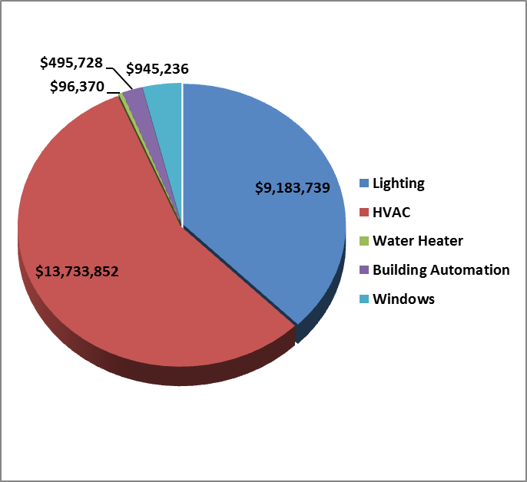

Figure - Distribution of Project Types for State Buildings

## HERO Program

In 1999, LDNR introduced the HERO Program, in which Louisiana residents received a rebate for making their homes more energy-efficient. With ARRA funding, the program was expanded to include new home construction, existing home retrofits, and commercial property retrofits. The expanded HERO Program was designed to support homeowners and businesses seeking to save money on energy and/or reduce their environmental impact through cash incentives for energy efficiency improvements.

**Benefit to Louisiana:** Increased energy efficiency to reduce energy costs and consumption; reduced reliance on imported energy

Louisiana’s HERO program achieved a total of 113,125.8 mmBTU of total energy savings utilizing $7.9 million in rebate funding. A total of 3,457 properties were ugraded through this program.

|  |  |
| --- | --- |
| **Funding Amount:** | $7,926,969 |
| **Expended:** | $7,926,969 |
| **Remaining:** | $0 |
| **Projects Completed:** | 3,457 |
| **LDNR Program Manager:** | Buddy Justice |

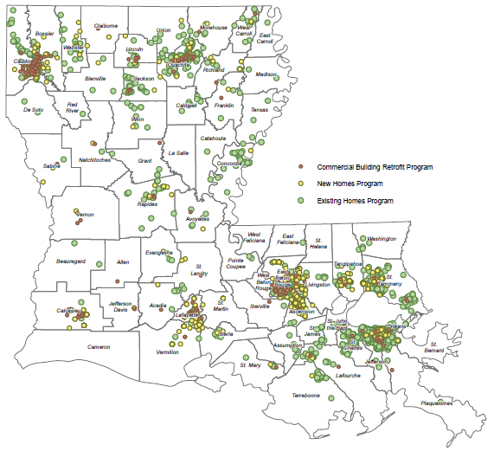

Figure – Geographical Distribution of all HERO Rebates

## Renewable Energy Grant Program

LDNR created the Renewable Energy Grant Program to encourage the development, implementation, and deployment of cost-effective renewable energy technologies in Louisiana; support the creation of additional employment opportunities; and stimulate market demand for other emerging renewable energy systems that meet certain eligibility requirements.

**Benefit to Louisiana:** Improved reliability of electricity and fuel supply and the delivery of energy services; reduced impacts of energy production and use on the environment

|  |  |
| --- | --- |
| **Funding Amount:** | $9,814,462 |
| **Expended:** | $9,814,462 |
| **Remaining:** | $0 |
| **Projects Completed:** | 6 |
| **LDNR Program Manager:** | Bryan Crouch |

Table - Awards and Outcomes for Renewable Energy Grants

|  |  |  |  |  |
| --- | --- | --- | --- | --- |
| **Renewable Energy Grants** | **Project Type** | **Funding Amount** | **Energy Generated (mmBTU)** | **GHG Emission Reduction (MTCO2E)** |
| **Agrilectric Power Partners, LP** | Biomass | $3,413,233.50 | 313,904.00 | 49,053.76 |
| **Cleco Power LLC** | Biomass | $1,000,000.00 | 3,272.86 | 511.45 |
| **Community Church Unitarian Universalist** | Solar Photovoltaic, Geothermal | $51,228.00 | 57.77 | 9.03 |
| **HRI Solar Leasing Inc** | Solar Thermal, Solar Photovoltaic | $2,100,000.00 | 3,262.04 | 509.76 |
| **Lamar Advertising of Louisiana, LLC** | Solar Photovoltaic | $2,250,000.00 | 3,197.54 | 499.68 |
| **University of Louisiana at Lafayette** | Solar Thermal | $1,000,000.00 | 105.18 | 16.44 |
| **Total** |  | **$9,814,461.50** | **323,799.39** | **50,600.12** |

## Transportation Efficiency & Alternative Fuels Program

LDNR created the Transportation Efficiency & Alternative Fuels Program to improve public infrastructure throughout the State of Louisiana by funding projects that will allow applicants to purchase or convert to alternative fuel vehicles, install efficient traffic signals and streetlights, and install alternative fueling infrastructure.

**Benefits to Louisiana**: Increased energy efficiency to reduce energy costs and consumption; reduced reliance on imported energy; reduced impacts of energy production and use on the environment.

|  |  |
| --- | --- |
| **Funding Amount:** | $7,781,270 |
| **Expended:** | $7,781,270 |
| **Remaining:** | $0 |
| **Projects Completed:** | 19 |
| **LDNR Program Manager:** | Bryan Crouch |

Table - Transportation Efficiency and Alternative Fuels Grant Amounts

|  |  |  |
| --- | --- | --- |
| **Subgrantee** | **Project Type** | **Funding Amount** |
| **City of Bossier City** | CNG Station & Fleet Conversion/Purchase | $1,643,648 |
| **Caddo Parish Sheriff Office** | Fleet Conversion/Purchase | $155,396 |
| **Clean Energy** | CNG Station | $691,124 |
| **Control Tech, LLC** | CNG Station | $10,000 |
| **Grant Parish Police Jury** | CNG Station/Fleet Conversion | $345,050 |
| **Lafayette Consolidated Government** | Fleet Conversion/Purchase | $717,141 |
| **Lafayette Consolidated Government** | CNG Station | $833,128 |
| **Lott Oil Company** | CNG Station | $555,210 |
| **Board of Commissioners Port of New Orleans** | Street Lighting | $3,768 |
| **Relay Stations, LLC** | CNG Station | $510,135 |
| **City of Shreveport** | CNG Station | $615,739 |
| **City of Shreveport** | CNG Station/Fleet Conversion | $834,246 |
| **City of New Orleans** | Street Lighting | $236,600 |
| **City of Alexandria** | Fleet conversion/ purchase | $14,900 |
| **St. Landry Solid Waste District** | Fleet conversion/ purchase | $551,200 |
| **DOTD** | Fleet conversion/ purchase | $28,358 |
| **DNR - Office of Conservation (Shreveport)** | Fleet conversion/ purchase | $10,628 |
| **DNR - Office of Conservation (Pipelines)** | Fleet conversion/ purchase | $25,000 |
| **Total** |  | **$7,781,271** |

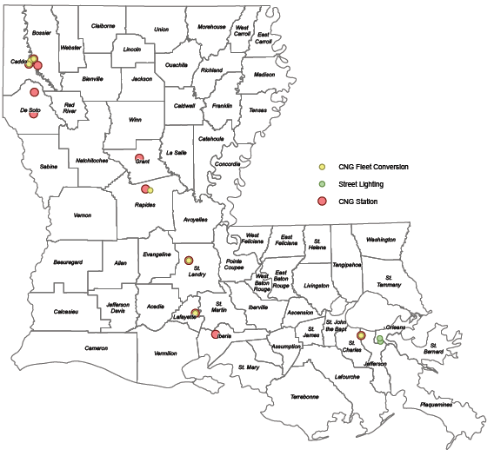

Figure - Geographical Distribution of Energy Efficiency Transportation Projects

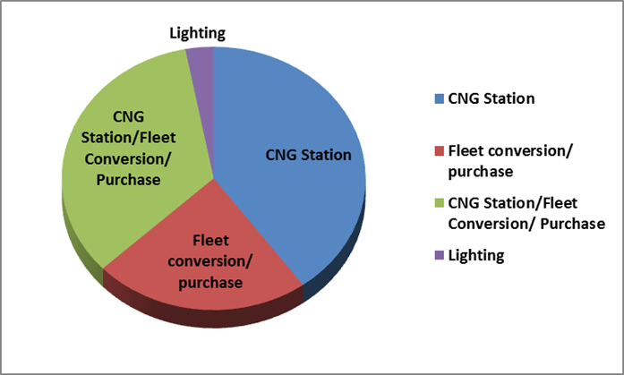

Figure - Distribution of Project Types for Transportation Efficiency & Alternative Fuels Program

## Revolving Loan Fund

The LDNR established the Flex-Fund Revolving Loan Fund to encourage implementation of cost-effective energy efficiency projects in Louisiana. The program provides low interest loans to qualifying Louisiana entities for qualified energy efficiency projects. Funding is available for commercial and industrial energy efficiency projects through a competitive revolving loan program.

**Benefit to Louisiana:** Increased energy efficiency to reduce fossil fuel emissions; reduced total energy costs and consumption; create and/or retain jobs; and spur economic growth.

|  |  |
| --- | --- |
| **Funding Amount:** | $12,725,382 |
| **Expended:** | $12,725,382 |
| **Remaining:** | $0 |
| **Loans Awarded:** | 2 |
| **Value of Awarded Loans:** | $4,099,739 |
| **LDNR Program Manager:** | Louis McArthur |

**Administrative Steps Taken:**

* Submitted amendments to DOE to increase program funding.
* Secured contract amendments with LPFA, the third party administrator for the Revolving Loan program to add funding.

**Outreach Efforts:**

* Advertised in six major newspapers.

**Funds Moved Into or out of the Program:**

* $12.7 million moved into Flex-Fund Revolving Loan Fund .

**Milestones on Horizon That Should Be Met:**

* Awarded two loans of $2,248,489 and $1,851,250 to Morehouse General Hospital and Ivan Smith Furniture, respectively. Negotiating with other potential loan recipents. All funds are transferred to third party (LPFA).

## Energy Efficiency and Conservation Block Grant Program (EECBG)

The LDNR established the Renew Louisiana EECBG Program to distribute available EECBG funding on a per capita basis as equitably as possible to units of local governments not eligible to receive a direct allocation from the DOE. The funding is distributed through local parish governments.

**Benefit to Louisiana:** Increased energy efficiency to reduce energy costs and consumption; reduced reliance on imported energy; improved reliability of electricity and fuel supply and the delivery of energy services; reduced impacts of energy production and use on the environment.

|  |  |
| --- | --- |
| **Funding Amount:** | $12,626,925 |
| **Expended:** | $12,626,925 |
| **Remaining:** | $0 |
| **Projects Completed:** | 60 |
| **LDNR Program Manager:** | Billy Williamson |

Table - Subgrantee Awards and Result Energy Efficiency Outcomes for EECBG

|  |  |  |  |  |  |
| --- | --- | --- | --- | --- | --- |
| **Subgrantee** | **Funding Amount** | **Energy Savings (Annual mmBTU)** | **Energy Generated (Annual mmBTU)** | **GHG Emission Reduction  (Annual MTCO2E)** | **FTE** |
| **Acadia** | $407,000 | 606.89 |  | 94.84 | 7.88 |
| **Allen** | $172,084 | 584.38 |  | 91.32 | 0.36 |
| **Ascension** | $266,718 | 515.25 |  | 80.52 | 2.37 |
| **Assumption** | $156,000 | 400.00 |  | 62.51 | 1.88 |
| **Avoyelles** | $216,854 | 75.44 |  | 11.79 | 11.72 |
| **Beauregard** | $230,279 | 137.68 |  | 21.52 | 1.69 |
| **Bienville** | $63,150 |  | 13.07 | 2.04 | 0.51 |
| **Bossier** | $129,000 | 684.22 |  | 106.92 | 1.71 |
| **Caddo** | $285,709 | 1,639.12 |  | 256.15 | 7.55 |
| **Caldwell** | $70,000 | 189.95 |  | 29.68 | 1.52 |
| **Cameron** | $45,588 | 12.32 |  | 1.92 | 0.47 |
| **Catahoula** | $292,000 | 432.76 |  | 67.63 | 15.52 |
| **Claiborne** | $110,000 | 173.99 | 63.55 | 37.12 | 1.37 |
| **Concordia** | $129,000 | 75.90 |  | 11.86 | 1.18 |
| **DeSoto** | $193,500 | 202.90 |  | 31.71 | 1.79 |
| **East Baton Rouge** | $564,703 | 132.56 | 156.00 | 45.09 | 2.24 |
| **East Carroll** | $31,151 | 52.01 |  | 8.13 | 0.21 |
| **East Feliciana** | $141,000 | 31.31 |  | 4.89 | 0.29 |
| **Evangeline** | $240,450 | 222.16 |  | 34.72 | 1.17 |
| **Franklin** | $136,000 | 1,661.42 |  | 259.63 | 0.06 |
| **Grant** | $142,718 | 319.69 |  | 49.96 | 1.14 |
| **Iberia** | $537,282 |  |  |  | 1.20 |

|  |  |  |  |  |  |
| --- | --- | --- | --- | --- | --- |
| **Subgrantee** | **Funding Amount** | **Energy Savings (Annual mmBTU)** | **Energy Generated (Annual mmBTU)** | **GHG Emission Reduction  (Annual MTCO2E)** | **FTE** |
| **Iberville** | $221,000 | 811.46 |  | 126.81 | 3.99 |
| **Jackson** | $149,711 | 653.67 |  | 102.15 | 0.87 |
| **Jefferson Davis** | $243,043 | 140.28 |  | 21.92 | 2.59 |
| **Lafayette** | $167,594 | 725.21 |  | 113.33 | 0.86 |
| **Lafourche** | $240,845 | 165.50 |  | 25.86 | 0.81 |
| **LaSalle** | $84,458 | 243.38 |  | 38.03 | 1.99 |
| **Lincoln** | $253,939 | 140.27 | 0.12 | 21.94 | 1.14 |
| **Livingston** | $325,725 | 253.09 |  | 39.55 | 1.24 |
| **Madison** | $79,707 | 139.23 |  | 21.76 | 0.85 |
| **Morehouse** | $195,000 | 212.37 |  | 33.19 | 2.22 |
| **Natchitoches** | $345,538 | 132.69 |  | 20.74 | 3.92 |
| **Ouachita** | $62,000 | 75.61 |  | 11.82 |  |
| **Plaquemines** | $146,000 | 110.02 |  | 17.19 | 1.68 |
| **Pointe Coupee** | $150,283 | 158.58 |  | 24.78 | 1.40 |
| **Rapides** | $258,424 | 239.94 |  | 37.50 | 0.52 |
| **Richland** | $138,984 | 23.69 |  | 3.70 | 2.57 |
| **St. Bernard** | $19,079 | 102.03 |  | 15.94 | 0.21 |
| **St. Charles** | $517,790 | 2,444.53 |  | 382.01 | 7.93 |
| **St. Helena** | $234,599 |  | 207.83 | 32.48 | 2.67 |
| **St. James** | $159,877 | 17.96 | 31.20 | 7.68 | 0.54 |
| **St. John the Baptist** | $323,925 | 213.97 |  | 33.44 | 2.68 |
| **St. Landry** | $235,961 | 1,325.07 |  | 207.07 | 3.81 |
| **St. Martin** | $347,325 | 191.15 |  | 29.87 | 3.71 |
| **St. Mary** | $346,670 | 907.00 |  | 141.74 | 1.20 |
| **Tangipahoa** | $298,000 | 400.33 |  | 62.56 | 0.67 |
| **Tensas** | $284,573 | 63.86 |  | 9.98 | 29.22 |
| **Terrebonne** | $885,000 | 932.66 |  | 145.75 | 8.47 |
| **Union** | $165,052 | 257.77 |  | 40.28 | 1.39 |
| **Vermillion** | $377,480 | 1,328.95 |  | 207.68 | 4.23 |
| **Vernon** | $116,932 | 1,735.59 |  | 271.22 | 1.55 |
| **Webster** | $277,877 | 453.10 | 166.39 | 96.81 | 2.29 |
| **West Baton Rouge** | $116,897 | 438.49 |  | 68.52 | 0.45 |
| **West Carroll** | $80,763 | 98.51 |  | 15.39 | 0.99 |
| **West Feliciana** | $92,526 | 1,594.74 |  | 249.21 | 1.74 |
| **Winn** | $124,160 | 83.72 |  | 13.08 | 1.66 |
| **Total** | **$12,626,925** | **24,964.37** | **638.14** | **4,000.93** | **165.89** |



Figure - Project Types for EECBG

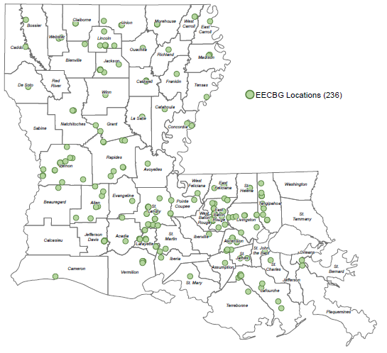

Figure - Geographical distribution of EECBG Funded Projects