AFFIDAVIT OF TEST OF CASING IN WELL
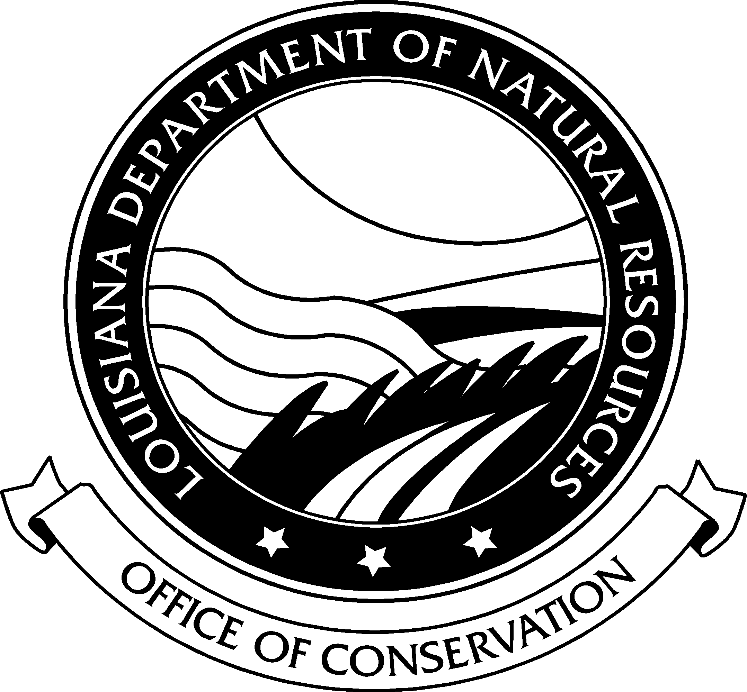
FOR SALT CAVERN WELLS ONLY
STATE OF LOUISIANA
OFFICE OF CONSERVATION
FORM – CSG-TSC
Date Work Done: |  |  |  |  |  |  |  |  | application number of approved work:
Operator Name and Address: |  |  |  |  |  |  |  |  | Operator Code:
 |  |  |  |  |  |  |  |  | Phone:
WELL INFORMATION
Well Name and No: |  |  |  |  |  |  |  |  | Serial No:
Field: |  |  | Parish: |  |  |  |  |  | Sec. |  | Twp. |  | Rng.
WELL CONSTRUCTION INFORMATION
Casing Size | Hole Size | Casing Weight |  | Make |  |  | Number of Threads/ Inch |  |  | Grade |  | Seamless |  | New or 2nd* Hand Pipe
* If second hand, was pipe tested:  Yes No |  |  |  | Describe:
Depth casing shoe landed below derrick floor: Ft. |  |  |  |  |  |  |  |  | No. of Sacks of Cement:
Size of Hole: |  |  |  |  |  |  |  |  | Amount of cement left in pipe:
Method of cementing: |  |  |  |  |  | Cement set in hours Under psig
Total Depth of |  |  |  |  |  |  |  |  | Total time set hours
DETAIL OF PRESSURE TEST BEFORE DRILLING PLUG
Date of Test: |  |  |  |  | stabilized casing pressure at START of TEST psig
casing Pressure at end of 60 minute Test psig |  |  |  |  |  |  |  |  | Pressure drop over test period psig  5% Maximum Allowable Pressure Loss
Test Fluid: Water Mud Weight: Viscosity:
Remarks:
CERTIFICATION BY OPERATOR
I certify under penalty of law that I have personally examined and am familiar with the information submitted in this form and that, based on my inquiry of those individuals immediately responsible for obtaining the information, I believe that the information is true, accurate and complete. I am aware that there are significant penalties for submitting false information, including the possibility of fine and imprisonment (L.R.S. 30:17).
Witness: |  |  |  |  |  |  |  | Operator Rep:
Signature: |  |  |  |  |  |  |  | Signature:

